The Final Project assignment is available as a downloadable Word file

Toolbox Terms and Concepts
The mandatory Final Project is designed for you to develop your toolbox of human geography terms and concepts.

The main purpose of GEOG 1191 is to introduce you to the contemporary geography of human-environment relationships. Part of this process is having you take a closer look at your own relationship with your environment. To understand this relationship through the lens of a human geographer, you are asked, in the Final Project, to identify, define, and demonstrate your understanding of key human geography terms and concepts.

You will be introduced to, and learn, key terms and concepts as you progress through the course. Key terms and concepts are presented in three main ways:

Through the highlighted terms used in each module and the course glossary

Through definitions of key words in the sidebars of the course textbook

Through the emphasis, in the textbook, of eleven key, recurrent concepts for the human geographer, in the Chapter 2 section “Human Geographic Concepts”

You are free to use one or all of these resources when selecting the key terms and concepts you will use in this project.

To demonstrate your understanding of these terms and concepts, you will select 20 examples and illustrate them using your own collection of images (photos and videos) from around your locale or from your travels. Aim for each entry to be approximately 200 words.

For each term or concept:

Define the term or concept in your own words.

Demonstrate understanding by writing one or two paragraphs applying your knowledge to a real-world example (approximately 200 words each). The real-world example will be from your locale or your travels and will be illustrated with a photo or video.

As appropriate, compare and contrast the term or concept with related terms or concepts (e.g., if you were writing about abiotic components of an ecosystem, you may elect to discuss biotic components. Your entire description of abiotic should not be just a comparison, however).

Use at least one external academic reference (journal articles, textbooks, reliable internet sources), not including your course textbook, for each term or concept. Reference using APA style, 6th edition.

Illustrate the concept by a photograph or video.

Create a map showing the location where the photograph or video was taken. You should submit one map containing all locations for the twenty terms and concepts. You are free to create your map, however you would like; you may use a screenshot, hand-draw your map, or use a computer mapping program. Your map should follow proper mapping standards, as discussed in this course, and include a:

Title
Scale bar or some other indication of scale

Legend

The final product will be a toolbox of terms and concepts, illustrated by examples that you have selected.

If you have other ideas or skills to bring to this assignment, discuss them with your Open Learning Faculty Member. For example, you may want to sketch drawings to illustrate your term or concept rather than use photos or videos.

The final draft of your Final Project will include an introduction and a conclusion, identifying the purpose of the assignment and its ties to human geography and the main themes and outcomes of this course.

You may submit your assignment in one of the following formats:
A single Word document. If you select this option, you will create a map and link your illustrations (through a key, legend, or other) to your map

A KML/KMZ (Google Earth) file providing a virtual atlas of your terms and concepts (here is an online resource for creating a KML/KMZ virtual atlas: http://www.google.com/intl/en/earth/outreach/tutorials/index.html).

If you have an idea for another appropriate format, feel free to discuss this with your Open Learning Faculty Member.

Example:
The key concept selected for illustrative purposes is globalization:

Globalization: Geography of My Breakfast

Human geographers study globalization as part of their interest in identifying what factors influence human behaviour. Globalization represents economic, political, and social changes that have increasingly brought people, and their impacts, closer together. One outcome of increased globalization can be seen every day in what we eat. Increased and more efficient transportation, built on a foundation of relatively cheap oil prices, has resulted in Canadians importing much of their food. For example, BC imports three times as much fruit as it exports (BC Ministry of Agriculture and Lands, 2006).

Below is an annotated photograph of my morning breakfast. As you can see, I would have a very different breakfast if I couldn’t import food and beverages. What was truly surprising was that I was unable to source the oatmeal to a specific country (despite an Internet search), and I could only source the yogurt to Calgary. An incomplete “Geography of Breakfast”!
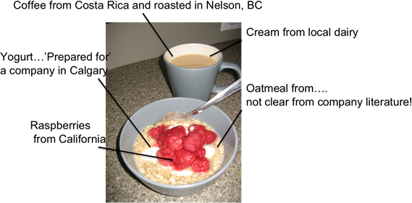

MP
Reference
British Columbia Ministry of Agriculture and Lands. (2006). B.C.’s food self-reliance: Can B.C.’s farmers feed our growing population? [PDF document]. Retrieved from http://www2.gov.bc.ca/assets/gov/farming-natural-resources-and-industry/agriculture-and-seafood/agricultural-land-and-environment/strengthening-farming/800-series/820105-1_bcfoodselfreliance_report.pdf.

The above example would be linked to an overall project map, Google Map point, or other.

Evaluation Criteria
You will be marked on assignment completeness, introduction/conclusion, use of secondary sources, presentation, as well as grammar, sentence structure, and structure.

Criteria

Value

Inclusion of 20 terms and concepts

1 mark each / 20 marks total

Introduction and conclusion

10 marks

Map: clarity of graphic used, title, legend, map scale bar

25 marks

Images used: photo, video, or other. Selection appropriateness—shows direct link to term or concept

20 marks

Grammar, sentence structure, spelling, and clarity of writing style

10 marks

Overall presentation and formatting (e.g., if essay format is used, photos should be uniformly presented using the same border width and colour, appropriate figure captioning and numbering used in text and under photos; if other format, then marks will be given for consistency and creativity of presentation)

10 marks

Correct APA citations and style

5 marks

Total

100 marks

