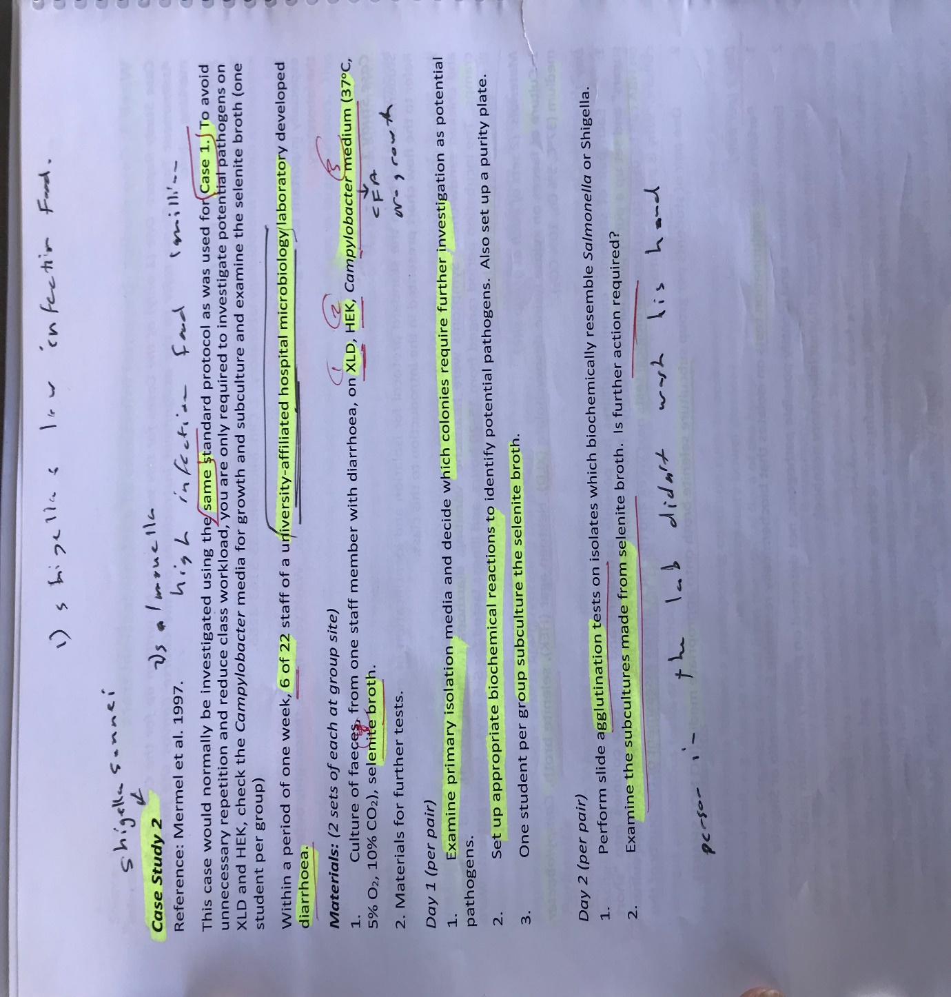
Assignment:
Write a Case study report. The task is to perform an identification to species level using appropriate enterics workflows and standard media and biochemical tests, and to a report on the case. This will require you to:
1. Identify the organism involved using appropriate media, workflow, biochemical tests.
3. Write a report on your case study and identification. You are required to describe the method, workflow and results of your identifications, and to discuss your findings. In addition, your discussion should cover the symptoms, pathogenesis and recommended treatment of the pathogen you identify.
Format The following headings should be used for your Case Study report:
• Introduction
• Materials and Methods
• Results
• Discussion
• References (Vancouver format).
Further details on what to include under these headings are given below. These guidelines can also be downloaded in PDF format here.
Please note correct formatting and referencing are part of the assessment criteria and marks will be deducted if format is not correct.

Introduction:
The introduction should include general background information including:
the significance infections of the particular body system (The Gastrointestinal Tract)
being studied, reasons for performing microbiological investigations on these patients, the importance of correct testing of antibiotic sensitivities, and expected outcome or benefit from such investigations.
The introduction should end with a brief statement that summarises the nature of the case that was investigated.
Outbreak food poisoning, to confirm diagnosis, a sample of faeces were send to the microbiology lab, performed gram stain test then cultured and examine under microscope, and for further biochemical tests
Materials and Methods:
You need to change all sentences and tables and diagrams in the report as it is copied from my partner report and that is not acceptable
Case study 2:
The unknown organism was identified as gram-negative rods organism by completing the gram stain procedure and microscopic morphology.
Further biochemical tests were carried out to distinguish species:

- Motility, indole and lysine tests: refer to Medical Microbiology Techniques Manual, RMIT Department of Biotechnology and Environmental Biology, 2013, p. 17.
- ONPG test: refer to Medical Microbiology Techniques Manual, RMIT Department of Biotechnology and Environmental Biology, 2013, p. 19.
- Urease test: refer to Medical Microbiology Techniques Manual, RMIT Department of Biotechnology and Environmental Biology, 2013, p. 26.
- Kliger iron agar (KIA): refer to Medical Microbiology Techniques Manual, RMIT Department of Biotechnology and Environmental Biology, 2013, p. 16.
- Mannitol peptone water: University of Melbourne, Microbiology Laboratory Techniques Manual, 2013, p. 52.
- Slide agglutination test: refer to Medical Microbiology Techniques Manual, RMIT Department of Biotechnology and Environmental Biology, 2013, p. 23.

Workflow:
Figure 1 shows the order of tests performed to identify pathogens associated with cases 1.
Primary observation
Colony growth/ morphology
Selenite broth turbidity

Biochemical tests
ONPG, Urease, mannitol peptone water, KIA and MIL
Subcultures and Purity plates
Morphological characteristics on subculture plates of XLD/ HEK split plates

Slide Agglutination test

Results:
Cultures of faeces plated on xylose lysine desoxycolate (XLD), Hektoen enteric agar (HEK), selenite broth and thiosulfate citrate bile sucrose ((TCBS) for case 4 only) incubated for 24 hours, under aerobic conditions and at 37C was provided. Campylobacter medium that had been incubated at 42 C, 5% O2 and 10% CO2 for 24 hours.

Figure 2 Colonial characteristics of non lactose fermenting organisms from cases 2.
Media | Case 2
XLD (O2, 37C, 24 hours) | Pink, large, rough and flat surface, crenated and entire edges
HEK (O2, 37C, 24 hours) | Green, small, rough and flat surface, crenated and entire edges colonies
Campylobacter medium (42 C, 5% O2, 10% CO2, 24 hours) | No growth
TCBS (O2, 37C, 24 hours) | N/A
Gram staining | Gram negative rods
Growth at HBA | Aerobic, 35 C 24Hr.  HBA - greyish in colour, Raised, round colonies
Growth at MAC | No growth on MAC, Non lactose fermenter

Table 2: Shows biomedical and serological tests for case 2.

Test Case Study 2 | Results
MIL  Motility  Indole utilisation  Lysine decarboxylation | Negative  Negative  Negative
Urease | Negative
ONPG | Positive
KIA  Acid from glucose  Acid from lactose  Gas production  H2S production | Positive  Negative  Negative  Negative
Mannitol peptone water | Positive, no gas
Slide agglutination test:  Shigella dysenteriae antisera  S. flexneri antisera  S. boydii antisera  S. sonnei antisera (group D) | No agglutination  No agglutination  No agglutination  Agglutination

The organism identified from case study 2 was Shigella sonnei.

Table 2: Incubation temperature / times
Oixdase test | ONP  Test | Urease Test | H₂S  Test | MIL  Test | Group antigen
2  second | 24C  48 Hr | 35 C  24Hr | 35C,O₂  24 Hr | 35C,O₂  48 Hr | 5-10 second

Purity plates and subcultures
Subcultures were prepared from inoculating XLD/ HEK split plates by obtaining colonies from the selenite broth.
Purity plates were obtained by inoculating horse blood agar (HBA)/ MCA (MacConkey) split plates with black colonies from XLD plate for case 1.

Discussion:
The discussion section should provide an interpretation of the results, including any unusual findings or difficulties in the identification. It should not contain extensive repetition of the results or of information in the introduction. A good way to discuss the results is to point out the critical tests that made it possible to identify the organism to genus and species level for example. If you had any unexpected results you should provide explanation and discuss how it could have been done better.

Make sure you discuss your findings in the context of the case notes you received. How does the organism you identified fit with the patient type, symptoms etc. The discussion section must also include a short discussion of the significance of the pathogen that was isolated in the case study under investigation, with appropriate reference to the scientific literature (approx. 3-10 references in Vancouver style). Your discussion should address the following points for each pathogen you isolated:
• How is the infection usually acquired?
• Symptoms, duration and possible complications of infection
• Brief discussion of how pathogenesis of infection leads to the symptoms
• Usual treatment recommendations and the implications for the patient in the case study you have chosen.
I write dot points for you to focus in these points in the discussion paragraph:
1-acurate identification of the causative agents of diseases of the GIT is vital in treatment
2-The unknown organism was identified as gram-negative rods organism by completing the gram stain procedure and microscopic morphology.
3-A further biochemical tests were carried out to distinguish species.

4-The isolated organisms were first cultured on HEK and XLD media to classify them as either non-lactose or lactose fermenters.
5-Colonies characterized by yellow color and small size were classified as lactose fermenters. Since lactose fermentation is a characteristic of the GIT normal flora, these colonies were discarded.
6-The remaining colonies were classified as pathogenic, non-lactose fermenters and therefore, were subjected to further tests for identification.
7- In Case Study 2, the pathogen had orange coloration on XLD but with small and greenish colonies on HEK. The pathogen was therefore suspected to be Proteus, Shigella, Providencia, or H₂S negative species of Salmonella
8-However, since the organisms had a negative urease test, as well as negative on motility, identification was considered to be Shigella

9- This conclusion was confirmed by the observed turbidity of the Selenite broth; which is used as an enrichment medium for Shigella organisms.
9- The organisms were further subjected to agglutination test by the use of anti-Shigella sonnei. The resulting agglutination confirmed that the organism in Case Study 2 was Shigella sonnei. On Indole test, the organisms gave a negative test. Since only Shigella sonnei is the only Shiggella species known to give a negative result of Indole test, the pathogen was confirmed to be Shigella sonnei.

11-patient history guided the correct and specific identification

Conclusion:
In conclusion, the aim of the study, which was investigating the pathogens that are associated. The results from case study indicated that the potential pathogens were Shigella sonnei,
The study indicates that several tests are necessary in the identification of pathogen are essential in the treatment of the gastrointestinal tract infections.

References:
In the course of preparing your report and researching the pathogen you have identified it is expected that you will have read some of the scientific literature on the subject. This might include a textbook, but should also include peer-reviewed journal articles, and/or a clinical laboratory manual. Web links from non- peer reviewed sources are NOT appropriate for a scientific report. Use the Vancouver format for your references. Please see the reference list for my document below for examples.

Submitting your Case Study Report
• Please combine all parts of your assignment into one word or PDF document and submit using the Turnitn link .

General formatting requirements for scientific reports:
• Organism names are always italicised.
• The first time an organism is mentioned by name, the name must be written out in full. Afterwards, the shortened version is used, for example, Escherichia coli then E. coli.
• The same applies to other abbreviations, for example calibrated dichotomous sensitivity first then CDS. You should use an abbreviation such as CDS only if it comes up at least five times in the text; otherwise write out in full.
• Be careful with the use of capitals. The only words that are capitalised mid-sentence are names of people, places or companies (Proper nouns). Incorrect usage; …. “were plated onto Horse Blood Agar (HBA)” correct usage …. “The organisms were plated onto horse blood agar (HBA)”.

References for these guidelines.
These are in Vancouver format!! 1. Williams H, Walduck AK, Deighton M, Lawrie A. RMIT Microbiology Techniques Manual 2013, 2nd Ed. RMIT University; 2013. 2. Jorgensen JH, Pfaller MA. Manual of Clinical Microbiology. Pfaller MA, Richter SS, Funke G, Jorgensen JH, Landry ML, Carroll KC, et al., editors. Amer. Society for Microbiology; 2015. 1 p. 3. RMIT University. RMIT Identification Tables for Bacteria. 2009.

As a rule, web sites are not peer-reviewed and are therefore not acceptable as references for a university report. Government health department web sites are acceptable if necessary, for example for quoting health statistics. (Eg. Health Department statistics, Centres for Disease Control, World Health Organisation)

NOTE: Appropriate reference for websites eg. CDC documents is below. URL is in this case actually part of the reference.
1. Author Surname Author Initial. Title [Internet]. Year Published [cited Date Accessed]. Available from: http://Website URL

