Case Study Background Information Transcript.
Getting to Know Jessica
Jessica is a 13-year-old girl who lives at home with her mother and her father, and her two older sisters— ages 14 and 16. The family lives in a rural environment about a half hour drive from the nearest town. Jessica attends a rural school in an inclusive grade six class and goes to and from school on the school bus. Jessica’s sisters ride the school bus with her to the elementary school, then change buses and continue on to their middle and high schools.
Jessica is currently enrolled in an inclusive grade six classroom and has been included with her peers since kindergarten. Jessica was identified as having autism spectrum disorder when she was two years of age because her communication skills and overall development were so delayed. She attended a preschool program for preschoolers with significant disabilities for 2 years. Jessica started kindergarten at age five with the support of an assistant. It was determined that it would be beneficial for her to stay in kindergarten for a second year before she went to grade 1 as she had very poor social and communication skills. Jessica is now in her third year of grade 5/6. Jessica responds very well to praise and point systems.
Jessica has been a very busy child. She enjoys outings in the community and travel with her family. Jessica likes swimming and other water activities very much. She has just learned how to paddle board and likes to paddle around a small lake near her house. Jessica also likes riding her ATV and uses the ATV to pick up the mail from the mailbox. She enjoys hikes if they are not too strenuous to long. Jessica has a black Labrador dog that she takes for walks.
Academic Skills
Jessica is very organized and keeps track of her personal belongings. Within the classroom, she is easily distracted by other students and items in the classroom. She has difficulties maintaining attention. Motivation is a significant issue for her in most school activities. She pays attention for a short period of time, then withdraws and engages in self-stimulatory activity with her hands.
Jessica becomes agitated when activities or schedules change without warning. She likes her environment to be consistent. Jessica manages her own materials but does not like anyone to touch or arrange her belongings. She is unable to get started on activities without support and needs support to continue. She is reluctant to ask for help.
Jessica cannot answer open-ended questions but can answer simple multiple choice or find the correct answer in a list. She likes to watch her peers but is very reluctant to participate and would rather sit by herself. She has a great visual memory but cannot remember things that are said to her. Jessica can follow simple directions but will sometimes choose to be noncompliant or will get distracted. She has difficulties following longer directions with several steps.
Jessica has a sight word vocabulary that is at the grade four level and she can read material up to the grade three level, with support to keep her focused on the reading. She loves to have stories read to her and her favorite stories are Harry Potter, and the Eragon series. She would like to be able to read books that are too difficult for her. Jessica has an excellent visual memory.

Jessica has difficulties printing. She cannot stay in the lines and gets very frustrated with how her letters look. Jessica has difficulties putting sentences together. She can copy words and put them together but cannot come up with words and ideas herself. A pencil grip and raised line paper have been used to help Jessica with writing. She is still very frustrated, and writing is very laborious.
Reading
- Reading words in isolation – grade four
- Reading passages out loud – grade two (cannot articulate most of the words)
- Listening comprehension – grade four
- Very interested in age appropriate books.
Math
- Counts to 20
- Can use a number line to add and subtract
- Understands number concepts to 10
- Cannot remember money values
- Difficulties reading a clock with hands.
Writing
- Likes to keep a journal.
- Finds it very difficult to write and stay in the lines.
- Cannot copy from far away. Finds it easier to copy from items very close to her. Likes to copy rather than write her own sentences.
- Can write simple sentences. Does better when there are words to choose from. Finds it difficult to come up with her own words.
Social
- Just completed social unit on mapping. On a multiple-choice exam/fill in the blanks with examples provided, she received a score of 78% on all of the concepts. She loves working with maps.
Science
- Just completed a science unit on compounds and chemicals. She did not do well. It was all a bit abstract for her. She did much better on a science unit where she could identify the types of animals and their habitats.

Life Skills
- Jessica is very independent. Takes care of her own needs such as dressing, eating, finding her way in the school, taking the bus, etc. But she does not like to wash or brush her hair. She is not concerned with personal cleanliness at all.
Problem Behaviours and Sensory Issues
Behaviours
Jessica has several self-stimulatory behaviours. When she is stressed, bored, or frustrated she rubs her fingers together. She will also engage in lip pulling for long periods of time, particularly at school. Sometimes she removes skin from her lips and causes them to bleed. Teachers at school tell her to stop touching her lips, but she continues. Jessica also has a fascination for hair. She has a number of Barbie dolls that she strips down and sits and caresses their hair for long periods of time. Jessica’s family allow her to have the Barbie dolls in her room and relaxation places in the home. They are not allowed into public places.
Likely, the most challenging behaviour to deal with is the way that Jessica ignores people in her environment. At school, she does not respond to teachers and other educational staff in her environment consistently. She also ignores the initiations of peers. At times she appears to be in her own world. Other times the ignoring is a compliance issue and she is choosing to not respond. Other times that lack of a response appears to be a language issue as she cannot find the words to respond to questions.
There are times when Jessica gets so frustrated that she engages in tantrum behaviour by crying endlessly and refusing to respond to others. This is usually when her belongings are touched or moved by others, or when someone has touched or said something to her that she is very unhappy about. Sometimes it takes a very long time for Jessica to return to a “normal” state of mind. She cannot “let go of the problem.”
Sensory Issues
Jessica has a very limited number of foods that she tolerates the taste and texture of. Her family has worked with her on accepting different foods, and although her range of foods that she likes has increased, her diet is still limited. This makes packing lunches for her very challenging and her participation in class cooking and party activities very limited. She also only likes her food a neutral temperature. She does not like things too hot or cold.
Jessica is also very sensitive to touch. She finds touch very irritating at times. She does not like her head touched, her hair brushed or washed, and she does not like to wear any kind of hat. She prefers loose, soft clothing and if she can, goes without socks or underwear. Her family has built acceptance of the hair brushing and washing, and the wearing of appropriate clothing into her routines, but Jessica reverts to her preferences when there is no supervision. Jessica also demonstrates an exceedingly high pain tolerance. She appears to not feel cuts, even when they are bleeding. She has also demonstrated a very high tolerance to pain following surgeries and was up and moving when she should have been bed ridden with pain.
Jessica also appears to have some difficulties with proprioceptive sensitivity. She struggles with inclines, steps, curbs, walking down hill, and uneven surfaces. She can be reluctant to proceed, and at times fearful.
Communication, Social, and Play Skills
Jessica’s communication skills are limited. She can speak and can say many basic phrases to express her needs. These phrases are mostly understood by everyone around her. She has a hard time answering open ended questions, but can respond to yes/no, and questions where she selects the best answer.
Jessica does not make eye contact in interactions with staff. When she needs help or wants attention, Jessica sometimes inappropriately tugs or touches the person she wants attention from. She is able to ask for help, but sometimes chooses not to. Jessica does not initiate contact with peers and often ignores comments or initiations from peers. She also does not initiate any social interactions with many of the staff and does not respond to staff when they initiate with her.
She watches other kids, and seems to enjoy watching on occasion, but does not interact.
Jessica is very isolated in class and in the halls. She is reluctant to participate in class discussions. She seems to prefer being by herself at recess, engaging in repetitive activities. She has difficulties understand the emotions of others. For example, she does not understand when to stop engaging in an activity when someone is getting mad or frustrated with her. She does not understand jokes or sarcasm.
Overall, Jessica’s social interactions are very limited. She does not like to make eye contact and does not approach others socially. She sits by herself at lunch and does not get involved in social activities. She struggles to come up with something to say when someone approaches her socially. She has difficulties with many social skills including asking for help, saying hello, responding to questions, and so on.
Jessica has always had limited play skills. As a child, she frequently lined things up. She particularly enjoyed lining up toy dishes and became extremely upset if anyone came near them. While she could eventually tolerate having others close to her and her toys, she continued to become upset if anyone touched them. Currently, she is able to fill her time playing on devices.
Technology
Jessica likes using the computer and when she can takes her sister’s iPhone and plays games and watches YouTube videos. She can navigate both the computer and the iPhone independently to play games if interest. Jessica would like to use the computer more but needs assistance for most of the software programs at home.
Various picture systems have been used with her, beginning in preschool. Jessica did not like carrying picture books with her, and they were often found hidden in different places when she got tired of them. When she was forced to point to pictures to communicate, she would; otherwise she would not use the pictures voluntarily. A visual schedule is used in the classroom. Jessica likes the schedule and refers to it during the day. She prefers to follow directions that are printed out. She uses the calendar to plan what she needs to do.
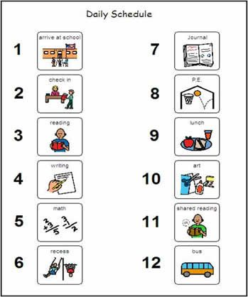
Example visual schedule used in early elementary 100%

alt text: Graphic of a 12-part schedule organized into two columns. The first column is numbered one to six, with number one labelled as “Arrive at School.” Number two, “Check In.” Number three, “Reading.” Number four, “Writing.” Number five, “Math.” Number six, “Recess.” The second column is numbered seven to twelve. Number seven, “Journal.” Number eight, “P.E.” or physical education. Number nine, “Lunch.” Number ten, “Art.” Number eleven, “Shared Reading.” Number twelve, “Bus.” With each number, there is a small illustration of things associated with school, such as a school building, teacher, or children playing.
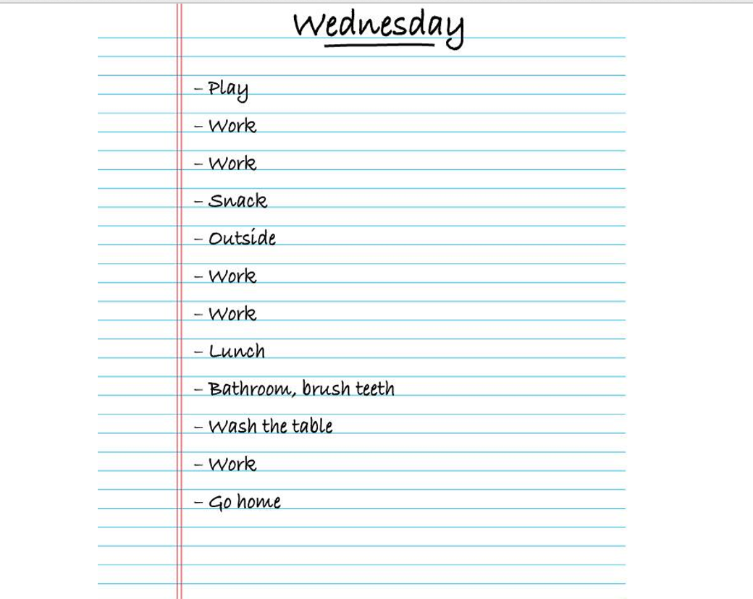
Example schedule currently used 100%
alt text: Graphic image of a loose-leaf piece of ruled paper with the heading “Wednesday” at the top. In a single column the words, Play, Work, Work, Snack, Outside, Work, Work, Lunch, Bathroom, Brush Teeth, Wash the Table, Work, and Go Home are listed.
A communication system on a laptop was implemented in grades one and two. Jessica refused to carry it around. She would use the system when forced to, but she tried to hide it in various locations. The teaching assistant found that the system on the laptop took too much time to set up.
A Vantage device was used in grades two and three. Jessica liked using the Vantage in the classroom but refused to take it home. The assistant did not have to spend time setting it up but was having difficulty remembering and using the symbols. At the end of grade three Jessica started using her voice to communicate, and the Vantage was abandoned.
