Chapter 4: Conceptual Design of the Narrow Track Vehicle
4.1. Introduction
The following chapter examines the conceptual design for the electric narrow track vehicle. Primarily, the chapter outlines the concept behind the design, the measurements selected, and vehicle dynamics. Also, since the focus of the study is mainly the rapid response vehicles that can operate under traffic congestion conditions, the chapter provides specifics that will aid in designing a narrow track vehicle incorporating parameters that will assist in attaining the dynamics. Specifically, the chapter examines the alternative solution to chassis and steering designs for narrow track vehicles, conceptual design, and final specifications for the selected electric narrow track vehicle.
4.2. Alternative Solution to Design Chassis and Steering System of a Narrow Track Vehicle
4.2.1 Chassis Designs
When building a car from an existing design or a new conceptual design, it is essential to assess the right specifications, especially for the vehicle's chassis. In this case, the factors that will be considered when analysing different chassis designs for a narrow track vehicle include the vehicle's ability to manoeuvre under congested traffic environment. Secondly, different designs examined should give the vehicles due to advantage in terms of speed and ability to cruise in various types of terrains given that the narrow track vehicles are purposely being designed for rapid response purposes.
The chassis system can be based on the five critical designs, including the ladder, backbone, monocoque, space, and combined designs. The ladder design assumes the shape of the ladder is the most common chassis design. On the other hand, the backbone design is whereby a substantial central component defines the entire chassis system and connects the front and the rear of the whole car frame. A backbone chassis is the exact opposite of monocoque design whereby the latter comprises of metal moulded from sheets of the material used for the rest of the car body. Hence, a monocoque chassis design is primarily used for unibody vehicles. On the other hand, a space chassis design is where the components are welded together to create a strong frame that also offers the vehicle some level of flexibility. Lastly, a combined chassis design system can borrow various components from the other four designs.
In electric narrow track vehicles, the designs can be categorized into three main types of chassis frames, including conventional, integral, and semi-integral frame. The conventional frame comprises of two extended side members with cross members joined together with rivets and bolts. A channel section is used when the aim is to develop a vehicle with excellent resistance to bending. On the other hand, a tabular section in conventional frames offers resistance to torsion while a box section can be used to provide excellent resistance to both bending and torsion. Integral frames are standard in ordinary vehicles. In this case, there is no chassis frame. Hence, all the units of assembly are directly attached to the boy of the car. Vehicles with this type of frame are cheaper and economical due to reduced weight. Nevertheless, the design makes repairs challenging. Lastly, a semi-integral chassis frame is whereby half of the frame is fixed in the front end where both the gearbox and the front suspension is mounted. Thus, in case of accidents, it is easy to remove and replace the damaged chassis frame.
Factors such as the load, the purpose of the narrow track vehicle and other specifications can determine the type of chassis design to use. In town-service narrow track vehicle, dynamic loading should be 2.5 to 3 times the static load and four times for off-road vehicles. The torsion of the vehicle should also be considered when designing NTVs. Both the rear and front axles experience a moment when the vehicle is traversing an uneven road. The loads at the lighter loaded axle are used to determine the vehicle's maximum torsion. Lateral and longitudinal loading is vital in chassis designs for NTVs. According to Rajpal et al. (2014), rolling over and toppling effect is a significant challenge for narrow track vehicle designs. Part of the vehicle design includes determination of the static stability factor (SSF) which refers to the ration of half of the vehicle width to the height of the centre of gravity. Calculating the static stability factor is key to determining the rollover resistance rating of the narrow track vehicle.
4.2.2. Steering Designs
Compared to ordinary vehicles, narrow track vehicles are likely to have reduced stability, especially when cornering. The reduced stability is likely to increase the chances for overturning based on the geometry of the narrow track width as well as a high centre of gravity compared to ordinary vehicles. To overcome these challenges, narrow track vehicles require an active control system to ensure that an appropriate leaning also known as the tilt stability is maintained during cornering without necessarily affecting vehicle handling procedures (Zhang, Gao and Zhu 2016). Therefore, active tilt and steer control will be used as an alternative steering design in this project. The strategy combines the action of both the tilting actuator and the traditional power steer. The strategy is useful as it ensures that the vehicle remains upright both at low and high speeds, especially when the vehicle self-leans during cornering and in tight spaces.
According to Tan, Arakawa, and Suda (2016), vehicle tilting is a typical characteristic of narrow track vehicles to maintain stability. Therefore, the vehicle will require considerable driving skills to balance between active steering and vehicle tilting for effective stability. Other factors that should be taken into consideration in steering design include the turning radius, steering response time, steering stability and resilience from external disturbance.
4.3. Procedure for Developing a Conceptual Design for Chassis and Steering for a Rapid Response Narrow Track Vehicle
The procedure provides a conceptual design for a rapid response electric narrow track vehicle. Some of the equipment that needs to be fitted in the vehicle for this purpose include sirens, reflective striping, communication radios, red and blue flashing lights, a navigation system, trauma kits, mobile data terminal, airway kits, oxygen, defibrillator, first aid kits and medications. In addition to the equipment, some of the safety features that the vehicle should have include reverse parking sensors, rearview camera and dynamic parking guidelines, SRS airbags, Emergency Stop Signal (ESS), and Autonomous Emergency Braking (AEB) with Forward Collision Warning System (FCWS). Additional safety features include Anti-lock Braking System (ABS) with Electronic Brake-force Distribution (EBD) and Brake Assist as well as Vehicle Stability Control (VSC) with Traction Control (TRC) and Hill-start Assist Control (HAC).
4.3.1. Chassis Design Procedure
The chassis frame is a vital component when designing the narrow track vehicle because it carries the stationary load that is attached to it. Besides, chassis withstands the torsional vibrations from the vehicle movement, a centrifugal force from cornering and bending stress resulting from the rise and fall of the front and rear axles. Also, the chassis frame design for a narrow track vehicle should be in a position to withhold various loads types of acting on it including loads resulting from turning, braking, quick acceleration, sudden accidents, head-on collisions, and vehicle overloading.
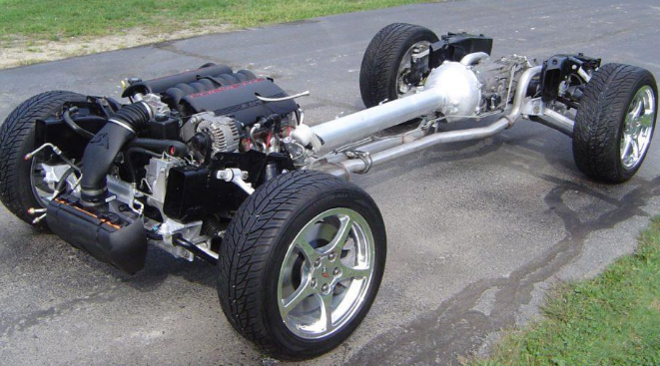
Figure 1: Chassis Frame
The chassis design selected for this project has a width of 1.5 meters and a capacity of between 2 and 5 passengers. The vehicle should have a storage capacity of between 350 and 425 kgs. The specifications are meant to support the purpose of the car, i.e. to move rapidly under tight spaces a top speed of between 150-190 km/h. A space frame will be used to make the chassis in this particular project. The reason for this choice is that space frames can be manufactured cheaply while damages to the chassis can be repaired easily (Abdullah, Najmi and Harun 2017). Hence, the overall cost of a narrow track vehicle will be reduced significantly when the space frame is used. Another advantage of using a space frame chassis in the project is on weight reduction compared to other types of chassis frames. Furthermore, it provides higher performance which is essential for rapid response narrow track vehicles.
- Rollover Prevention Technologies
One of the factors to consider in this project is the safety of the narrow track from rollover or toppling effect when designing the chassis. The centrifugal force exerted on the chassis of the narrow track vehicle, especially during cornering can contribute to lateral bending. The existing rollover prevention technologies that can be used in narrow track vehicles include direct control of the vehicle roll motion through an active suspension, stabilizer or anti-roll bar which tends to raise the rollover threshold. The second type of rollover prevention technologies includes those that indirectly influence roll motions. It can be achieved through control of yaw motions through active front steering and differential braking. The latter will be used in this project. Unified Chassis Control (UCC) algorithm will be applied when designing the NTV because it will help prevent rollover, ensure lateral stability and excellent maneuverability.
- Suspension Systems
Suspension geometric concept.
Over the years, vehicle suspension systems have evolved from simple designs such as the solid beam axles to more complex multilink designs that have bushings (Putten 2009). In this design, the conceptual choice uses a combination of maximal design with comprehensiveness. Hence, the vehicle will be equipped with both four-wheel steering and four-wheel drive. The selected design will provide the electric narrow track vehicle with all essential properties. Another reason why the design was chosen is that it will provide a solid basis in case further research is needed in relation to multilink systems.
Front suspension- MacPherson structure
The two types of suspensions that will be used in this rapid response narrow track vehicle include the MacPherson strut for the front and torsion beam for the rear suspension. Macpherson struct was selected as the front suspension system because of its simplicity, stiffness and fewer space requirements. The suspension system comprises of spring suspension mounted on a shock absorber, pivoted at the ballpoint while the end is connected to the body (Dutta 2017). A single transverse arm will be used for this connection.
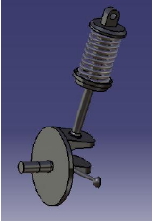
Figure 2: Macpherson Strut suspension system.
In the suspension, the two of the links will be taking the lateral load of the NTV while the other link will be taking the drag load. The spring is positioned around the struct, which will act as the hydraulic damper. As it rotates around at the struct ball joint, steering will be possible. In this project, the MacPherson strut suspension will be used at the front wheels in order to create more space for battery mounting. The battery rating selected for this project will have a score ranging between 14,000 and18,000 mAh.
Rear Suspension- Torsion Beam
It is also known as the twist-beam rear suspension. One of the reasons why this rear suspension system was preferred for this project is its low cost. Thus, it is commonly used in cheaper or entry-level vehicles. The two trailing arms at the rear will be joined by a cross member, which is part of the chassis. Torsion-beam suspension is also perfect for this rapid response narrow track vehicle because the cross member will also act as an anti-roll bar. Additional advantages of torsion beam suspension include its lightweight, which is vital in saving fuel (Huh 2009). The NTV will have an engine displacement of between 1000 and 1200 cc. Hence, the torsion beam suspension is perfect for the project. Also, the suspension is durable and straightforward, requiring fewer bushings.
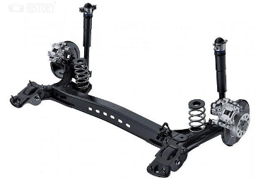
Figure 3: Torsion-beam rear suspension
iii. Braking System
The two standard braking systems used in a vehicle include drum brakes and disc brakes. In a disk brake system, the brake pads squeeze the rotor instead of the wheel. In addition, the force is transmitted hydraulically. On the other hand, drum brakes have metal drum enclosing the brake assembly in each wheel. In the conceptual design, the disk brake system will be used. The front brake will be composed of ventilated discs while the rear brake will have solid discs.
Ventilated discs front brakes
The ventilated discs were selected for the project because they are stable with an efficient mechanism. A calliper clasps the discs and in turn, hold the brake pads. A lot of heat is generated in the process, and therefore, the temperature of the disk brake may rise up to 500 °C. Hence, the ventilation of the front discs is vital for better cooling. Nevertheless, the disk brake rarely fades. In this rapid response narrow track vehicle, the ventilated discs were preferred for the front braking because they are reliable and can guarantee a safe reduction of speed. Furthermore, the disc brakes remain effective even after many braking cycles as a result of the internal ventilation.
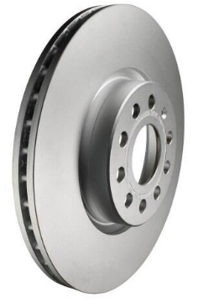
Figure 4: Ventilated disc brake
Solid disc rear brake
The solid disc brakes were selected in this project mostly because of their simplicity. They are mainly made up of a solid block of iron. Since their manufacturing process is cheap, the a more affordable which further reduces the cost of a narrow track vehicle.
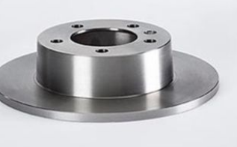
Figure 5: Solid disc brake
- Transmission System Summary
The three main parts that will make up the transmission system of the electric narrow track vehicle include a motor, a battery and an inverter. The vehicle battery to be used will have a rating of between 14,000 and 18,000 mAh. This will help maintain the vehicle’s all-electric range of 40-80km. The electric design will allow the vehicle to work on any speed as it does not require a speed varying transmission hence necessary for rapid response purposes. The power generated in the electric vehicle motor is transferred to the drive wheel via gearbox while the energy is stored in the battery after conversion.
4.3.2. Steering Design
When designing the steering system, some of the areas considered include its ability to turn the vehicle with fewer efforts and more mechanical advantage. In addition, the steering system should be able to turn the wheels within the shortest possible time, have a self-centring action within the steering geometry, and have a certain degree of irreversibility to ensure that the shock arising from the road surface is not transmitted to the hands of the driver. Among the technologies that may be included in the electric narrow track vehicle to improve handling include Electronic Stability Program (ESP), driving torque vectoring and electronic Limited Slip Differential (eLSD) (Putten 2009). Inclusion of these technologies in the narrow track vehicles will offer more safety improving potential.
- Steering Mechanical System
Two of the steering conceptual designs explored include Direct Tilt Control (DTC) and Steering Tilt Control (STC). In DTC, the system is based on a dedicated actuator which is mounted on the longitudinal axis of the narrow track vehicle. Hence, it provides a torque to tilt the vehicle. On the other hand, a steer-by-wire system is required in STC actuator (Mourad, Claveau and Chevrel 2014). Hence, the steering angle, which is applied by the driver, is modulated by the STC system. In this project, a Steering Tilt Control will be used as the mechanical steering system of choice. The reason is that STC is more suitable for rapid response vehicles and less suitable for vehicles with low longitudinal speeds of less than 8 m.s. ⁻¹ Hence, a large counter-steering is required in this case to tilt the vehicle, which can potentially deviate it from the trajectory. Steering Tilt Control is more adaptable for high-speed rapid response narrow track vehicles. In this project, the front wheels will have a turning radius of between 4.6 to 5.4 m.
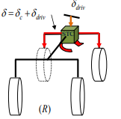
Figure 6: Steering Tilt Control (STC) system
δ = Steering angle of the front wheels
δ_{dri} = steering angle provided by the driver
δ_{c} = Steering angle modulation generated by the STC system
- Four-Wheel Steering
A four-wheel or a rear-wheel steering system helps in moving the vehicle’s rear tires a couple of degrees in orders to improve handling. During low speeds, the rear wheels steer in the opposite direction of the front wheels (Sethupathi, Chandradass and Praketh 2018). In developing a four-wheel steering mechanism in the narrow track vehicle, a rack and pinion for the front wheels with a connector turning the rear wheels will be used. Hence, the rear wheels will be controlled using tie rods while the front wheels will be converted using a basic rack and pinion mechanism. The slot fixing the two sets of wheels will be placed in such a way that it is free to rotate on its own from a central axis. This design is critical in a narrow track vehicle as it two phases can be achieved; out-phase and in-phase.
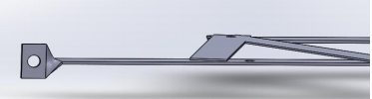
Figure 7: The front end of a steering link
. 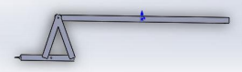
Figure 8: Steering link
The four-wheel steering system improves handling in rapid response narrow track vehicles. In this project, the four-wheel steering system whereby the steer angles of the rear wheels are derived from the front wheel angles is preferred as a strategy to improve steering efficiency and general handling of the vehicle. A four-wheel steering mechanism will ensure that the turn angle of the rear wheel is enough to assist the motion of the front wheels without necessarily providing own direction.
4.4. Concluding Remarks
From the above procedure, both the steering system and the chassis of the vehicle are vital components. They support vehicle dynamics as well as links to other systems of the vehicle. The chassis and steering designs vary slightly in electric narrow track vehicles by the inclusion of support mechanisms to facilitate tilt and increase vehicle handling and stability. Further research is necessary especially under the four-wheel steering system to find ways to reduce the turning radius of the wheel to make the vehicles much easier to handle and maneuver in tight spaces on a high speed, especially when responding to emergencies.

References
Abdullah, M., Najmi, M., and Harun, M., 2017. Chassis design and analysis of narrow track vehicle. Proceedings of Innovative Research and Industrial Dialogue, 177-178.
Dutta, P., 2017. Design and Analysis of three wheeled vehicle chassis (Unpublished doctoral dissertation). North Eastern Regional Institute of Science and Technology,
Huh, H., 2009. Engineering Plasticity and Its Applications from Nanoscale to Macroscale: Proceedings of the 9th AEPA 2008, Daejeon, Korea, 20-24 October 2008. Toh Tuck Link, Singapore: World Scientific.
Mourad, L., Claveau, F., and Chevrel, P., 2014. Direct and steering tilt robust control of narrow vehicles. IEEE Transactions on Intelligent Transportation Systems, 15(3), 1206-1215. doi:10.1109/tits.2013.2295684
Putten, B., 2009. Vehicle dynamics analysis and design for a narrow electric vehicle (Doctoral dissertation, Eindhoven University of Technology ).
Rajpal, J., Thorat, S. G., Kothavale, B. S., and Hatwalane, S. S., 2014. Design considerations for automobile chassis for prevention of rolling over of a vehicle. Applied Mechanics and Materials, 612, 41-49. doi:10.4028/www.scientific.net/amm.612.41
Sethupathi, P., Chandradass, J., and Praketh, G., 2018. Design and fabrication of four wheel steering system for light motor vehicles. In IOP Conf. Series: Materials Science and Engineering 402.
Tan, J. T., Arakawa, H., and Suda, Y., 2016. Steering dynamics of tilting narrow track vehicle with passive front wheel design. Journal of Physics: Conference Series, 744(5), 012218. doi:10.1088/1742-6596/744/1/012218
Zhang, P., Gao, L., and Zhu, Y., 2016. Study on control schemes of flexible steering system of a multi-axle all-wheel-steering robot. Advances in Mechanical Engineering, 5(4), 35-41.

