Identify an organization that could benefit from the application of the I/O Model of Above-Average Returns (Figure 1.2 on page 15 in the text). Follow the five steps to justify your answer. Do not use Apple or Walmart in this exercise. Be sure to incorporate the relevant vocabulary or terms from the chapter and give us the "why".
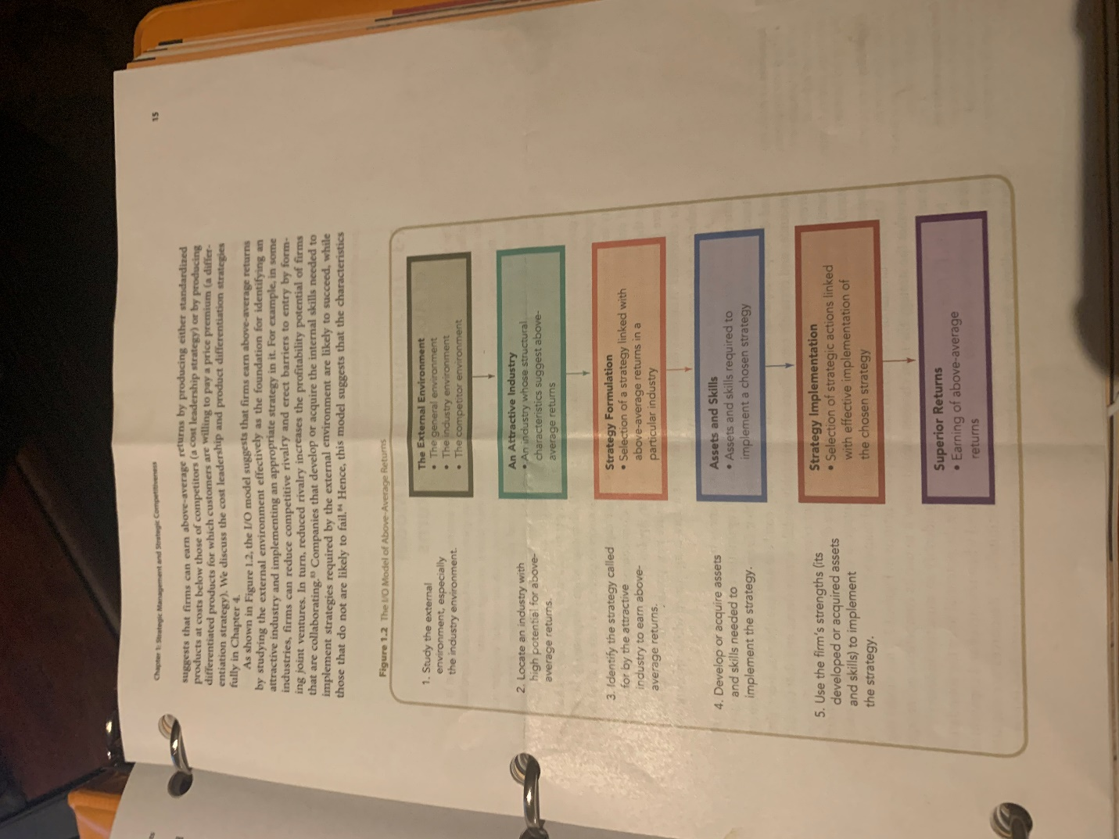

1 .Can any firm beat Amazon in the marketplace? If not, why not? If so, how can they best do so? How formidable a competitor is Google for Amazon? Please explain. What are Amazon's major strengths? Does it have any weaknesses? Please explain. Is Jet.com a potential concern for Amazon? Why or why not?
- Given the importance of understanding the external environment, why do some firms fail to do so? Provide examples of firms that did not understand their external environment. that were the implications of the firm's failure to understand that env

Click here to watch the video | Today, there are several options for people who want to pursue a legal claim. This includes filing a lawsuit in court, but also includes alternative forms of dispute resolution (referred to as ADR) such as mediation and arbitration. In both mediation and arbitration, the dispute is resolved outside of court, with the main difference being that mediation requires the parties to voluntarily agree to a resolution, while arbitration requires the parties to abide by the decision of a private arbitrator.  For this discussion, choose one of the disputes listed below and explain whether you think the best way to resolve it is through a lawsuit, mediation, or arbitration.  - A woman is passed over for promotion and instead the job is award to a man with less experience. She believes that this is a case of sex discrimination.  - A truck driver is hit by a motorist who ran a stop sign and will be in the hospital for several months and does not have any savings or disability benefits.  - A child is injured when a very popular folding high-chair collapses, and it appears that the high-chair was improperly designed and unable to reliably support the weight of the average infant.
Reply

