Coursework Questions:

The coursework comprises of a 1000-word individual essay on the below.

Compare and contrast the real self versus the ideal self. The essay should discuss both types for any ONE or both of the following product categories, discuss which self is likely to be used as a reference point and the individual decision-making process when the purchase decision is being considered:

- Food products (vegan food products)(three example )

Content of Assignment:

- Title page
- Content
- Introduction (max 150 words) (what report will do, highlight what is vegan(two to three sentences),Discuss real/ideal come up in vegan industry)
- Main Body(may need picture to support the evidence ) (max 750 words) (definition of real and ideal(both write two to three sentences) (compare example one product(McDonald’s)+compare ideal or self by the video or company website +why is ideal,self or both (not own opinion ,need evidence + Argument(focus on discussion section to find out justifications for your argument) +how does the image consider consumer decision making process(ideal or self or both) +Theories)(Example 2(Ed’s Diner)….)( Example 3(TGI Fridays)….)(if there have two product in the same self ,then write self first and DMPat final )
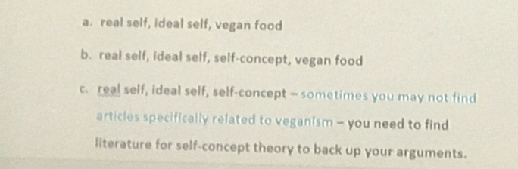
- Conclusion (max 100 words)
- References

Important Information:

- To pass this coursework you will need to demonstrate:
- The ability to access and research appropriate academic literature.
- The ability to APPLY theories of consumer behaviour or to apply to the essay what was read in the appropriate academic literature
- Skills of analysis, compilation and structure.
- Essays should be more than descriptive collations of library material and should illustrate relevant aspects of theory and practice, and demonstrate thoughtful and critical analysis of issues.
- Marks will be therefore be awarded for evidence of:
  - good research skills and the effective use of appropriate literature throughout the essay
  - analytical rigour (good analytical skills)
  - a critical perspective throughout the essay
  - demonstration of understanding of all relevant concepts
  - good application of theory to practice
  - use of appropriate examples throughout the essay
  - practical insight.
- You need to read at least 5-8 peer-reviewed journal articles for this essay. Use relevant theory to support your it.
- I will be expecting to see references on EVERY page. Use 2-4 references for each argument you make. Relying on ONE author/paper for an argument is not good academic practice.
- Your main source of research should be journal articles, but 1 or 2 book references are allowed. Website references ARE NOT allowed as the academic rigor of many websites is questionable. Note that GOOGLING is not an appropriate research method, and sites like Wikipedia are completely .
- Use Google scholar (souces after 2016)
- Quotes must be indented where appropriate. Please note that while a few quotes help you make your argument, too many quotes will result in a loss of marks. I want to mark YOUR work not a list of quotes!
- Essays must be double-line spaced and justified throughout.

Assessment Information

This assignment is designed to assess learning outcomes:

Students must:
1. Demonstrate an understanding of the main theories in consumer behavior(hierarchy of needs, group influence, perception,self-image etc.) and how these can be applied in marketing endeavors.
2. Understand the psychological underpinnings of consumer behaviour.
3. Produce a critical analysis of a contemporary issue in consumer behaviour.

CW: Individual Essay will collectively assess intended learning outcomes 1-3.

Criteria for Assessment
Class | Mark range | Guidelines
Class I | 90 – 100%  80 – 89%  70 – 79% | In addition to that for 70 – 79% below, an outstanding answer that could hardly be bettered. High degree of understanding, critical/analytic skills and original research, where specified. Outstanding in all respects.  In addition to that for 70 – 79% below, the answer will demonstrate an excellent level of understanding, presence of clear description, critical/analytical skills or research, as appropriate.  Answer entirely relevant to the assignment set. Answer will demonstrate clear understanding of theories, concepts, issues and methodology, as appropriate. There will be evidence of wide-ranging reading and/or research, as appropriate, beyond the minimum recommended. Answers will be written/presented in a clear, well-structured way with clarity of expression. At level 3, evidence of independent, critical thought would normally be expected.

