Critical Thinking and Communication

Final Essay and Argument Diagram

Weighting: 30% of Final Grade (25% Essay, 5% Diagram)

Word Count: 1,200 +/- 10% (footnotes, referencing and direct quotes do not count towards the word-count)

Format: Preferably APA, 12pt, Times New Roman – or another nice font; definitely double-spaced; definitely third-person; definitely formal, academic style

Question: Is it reasonable to believe in [UFOs]?

Additional requirements 1. Footnotes explaining the application of Critical Thinking Considerations (page 2, included in 25% grade for essay—these explanations do not count to your word-limit)
2. Argument diagram in Appendix (page 2)

Your tutor will give you a controversial topic at random—some people believe your topic is true, some people believe your topic (or elements of your topic) is not true. You will need to briefly describe your topic and critically compare the evidence put forward by each side.

You will be judged on your ability to critically analyse your topic, specifically: you must state the claims made by people who believe in your topic (and list the reasons/evidence they provide for these claims); then compare this evidence with the evidence for the claims made by the people who do not believe in your topic; and give reasons why it is either rational or irrational to believe in the topic (or, if your topic is complex, describe exactly which of the claims are reasonable and which are not—or to what extent certain claims should be believed or not).

As each of you has a different topic, it is difficult to prescribe the format your essay should take. Through researching your topic, you may discover that there is overwhelming evidence against those who believe it, and in this case you would spend a little more of your time explaining why it is that people would begin to believe in something so patently absurd. Alternatively, you may find that neither full belief nor full disbelief appropriate—in which case you would argue where believe is reasonable (and where is not), and to what extent, and why.

You are not marked on your ability to describe the topic, but rather how you provide two sides of a case, then judge which is the strongest and provide reasons for your judgment—remember: this is an argumentative essay. You are not graded on the position you take, but rather on how you support your arguments and address relevant counterarguments.

- You will be graded on your ability to answer the question in a formal, academic essay style. Lectures and tutorials will be used to help you do this, and SLS is available for additional help.
- You must provide appropriate citations.

Critical Thinking Considerations

Critical Thinking Considerations:

- Extraordinary Claims Require Extraordinary Evidence (ECREE)
- Occam’s Razor (all things held equally, the simplest explanation is the best)
Each of your topics has been criticised for failing to meet/account for the requirements.

In your Essay and Diagram, you are to provide a footnote when you address these criticisms (agreeing/disagreeing, etc.) with an explanation why the critical thinking consideration is the relevant. Here is an example, with the footnote at the bottom of this page:

… Many people have claimed to have seen Bigfoot; however, it is unreasonable to believe in the existence of Bigfoot solely based on eyewitness testimony. …

Argument Diagram
Embed this within your Final Essay as an appendix. You are to write your thesis at the bottom middle of the page. This can be done by hand and then attached as a photograph/scan to your paper, or you can use text boxes in word. You are then to support the reasons given for your thesis and attack/refute the main reason(s) against your thesis. Further details will be given in tutorials.
Format and Rules:
Arrow Rules
- If you can’t read “because” when you jump upwards, it’s wrong
- If you can’t read “therefore” when you jump downwards, it’s wrong
- Your arrows must point towards the thesis (downwards)
Content Rules
- If it’s general at the top, it’s probably wrong
- If it’s specific at the bottom, it’s probably wrong
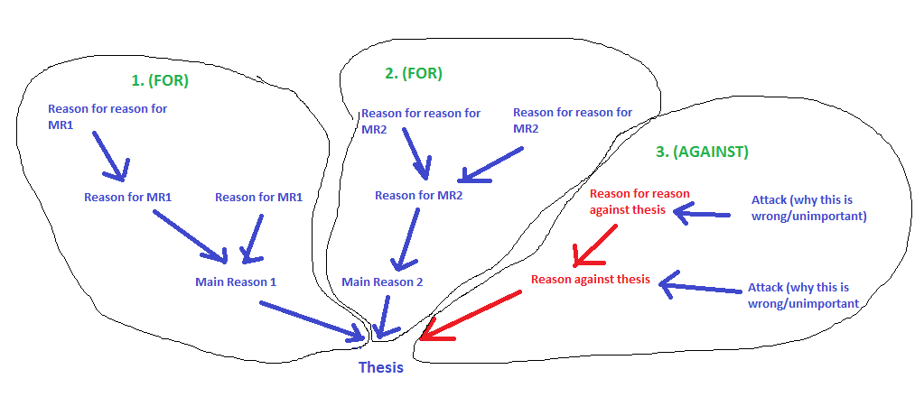
Simplified example of diagram

Hume, Of Miracles: Eyewitness testimony is notoriously unreliable. The existence of a giant humanoid roaming the woods would be more miraculous than the eyewitness testimony being based on fraud or faulty observation. As such, the Hume, Of Miracles Critical Thinking Consideration suggests it is reasonable to reject the greater miracle (in this case, the existence of a giant humanoid roaming the woods).

