Laboratory N° 3

**Biological Buffers II–Preparation of a Phosphate Buffer**

When the concentrations of the conjugate acid and base of a buffering compound are equal, then pH = pKa. This is the point of maximum **buffering capacity** of the solution. This is most obvious when a titration curve of the substance is generated by the titration of a buffer of a known concentration with varying amounts of a strong acid or base. For a monoprotic buffer (i.e. made from a weak acid that contributes only a single proton, such as CH3COOH) the titration curve will look similar to that in Figure 3 but the volume of base required will vary depending on the initial concentration of the acid. For acids whose physical state is liquid in laboratory conditions, one must factor in their density ( = m/v) and, in some instances, their purity (if it is considerably lower than 100% v/v).

**Blood buffers[1],**[2]

An excellent example of buffer capacity is found in the blood plasma of mammals, which has a remarkably constant pH. Consider the results of an experiment that compares the addition of an aliquot of a strong acid to a volume of plasma with a similar addition of strong acid to either physiological saline (0.15 M NaCl) or water. When 1 mL of 10 M HCl is added to 1 L of physiological saline or water that is initially at pH 7.0, the pH is lowered to 2.0 (in other words, H+ from HCl is simply diluted to 10-2 M). However, when 1 mL of 10 M HCl is added to 1 L of human blood plasma at pH 7.4, the pH is lowered to only 7.2 (impressive evidence for the effectiveness of physiological buffering).

The bicarbonate/carbon dioxide (HCO/CO2) system is one of the two major blood buffers, the other being the protein hemoglobin. Carbonic acid (H2CO3) ionizes as a typical weak diprotic acid:

H2CO3 ⇌ HCO + H+ ⇌ CO + H+

However, most of the conjugate acid[3] dissolved in blood and cytoplasm is present as CO2, not H2CO3. The dissolved CO2 is in equilibrium with CO2 in the gas phase:

|  |  |  |  |  |  |  |  |  |
| --- | --- | --- | --- | --- | --- | --- | --- | --- |
|  | *k* |  | *Keq1* |  | *Ka1* |  | *Ka1* |  |
| CO2 (gas) ⇌ CO2 (dissolved) + H2O ⇌ H2CO3 ⇌ HCO + H+ ⇌ CO + H+ | | | | | | | | | |

The equilibrium between CO2 (gas) and CO2 (dissolved) is given by:

[CO2]dissolved = *k* (*P*CO2)

That is, the concentration of dissolved CO2 is directly proportional to the partial pressure of CO2 (*P*CO2) in the gas phase. At 37°C and an ionic strength of 0.5, *k* = 3.01 X 10-5 when *P*CO2 is expressed in terms of mm Hg.

The equilibrium constant for the reaction CO2 (dissolved) + H2O ⇌ H2CO3 is about 5 X 10-3:

|  |  |  |  |
| --- | --- | --- | --- |
| *Keq1* | = | [H2CO3] | = 5 X 10-3 |
| [CO2]dissolved |

Thus, the overall equilibrium constant between dissolved CO2 and HCO + H+ is given by:

|  |  |  |  |  |
| --- | --- | --- | --- | --- |
| *K* | ’ *a* | = | [HCO][H+] | = *Keq1* X *Ka1*= (5 X 10-3)(1.58 X 10-4) = 7.9 X 10-7 |
| [CO2]dissolved |
|  |  |  |  | |  |  |  | | --- | --- | --- | | ∴  p*K* | ’ *a* | = 6.1 | |

At any pH:

|  |  |  |  |  |  |
| --- | --- | --- | --- | --- | --- |
| pH | = 6.1 + log | [HCO] | and pH | = 6.1 + log | [HCO] |
| [CO2] | (3.01 X 10-5) *P*CO2 |

For all practical purposes, a bicarbonate buffer can be considered to be composed of HCO (conjugate base) and dissolved CO2 (conjugate acid).

The pH of blood is maintained at about 7.4. If the p of CO2 is 6.1, how can the HCO/CO2 system help buffer blood at pH 7.4? (Remember that a buffer is supposed to be effective only in the region of its pKa.) In vivo, the HCO/CO2 is an open system in which [CO2]dissolved is maintained constant. Any excess CO2 produced by the reaction HCO + H+ H2O + CO2 is expelled by the lungs. In contrast, the usual laboratory buffer is a closed system: The concentration of conjugate acid increases when H+ reacts with the conjugate base.

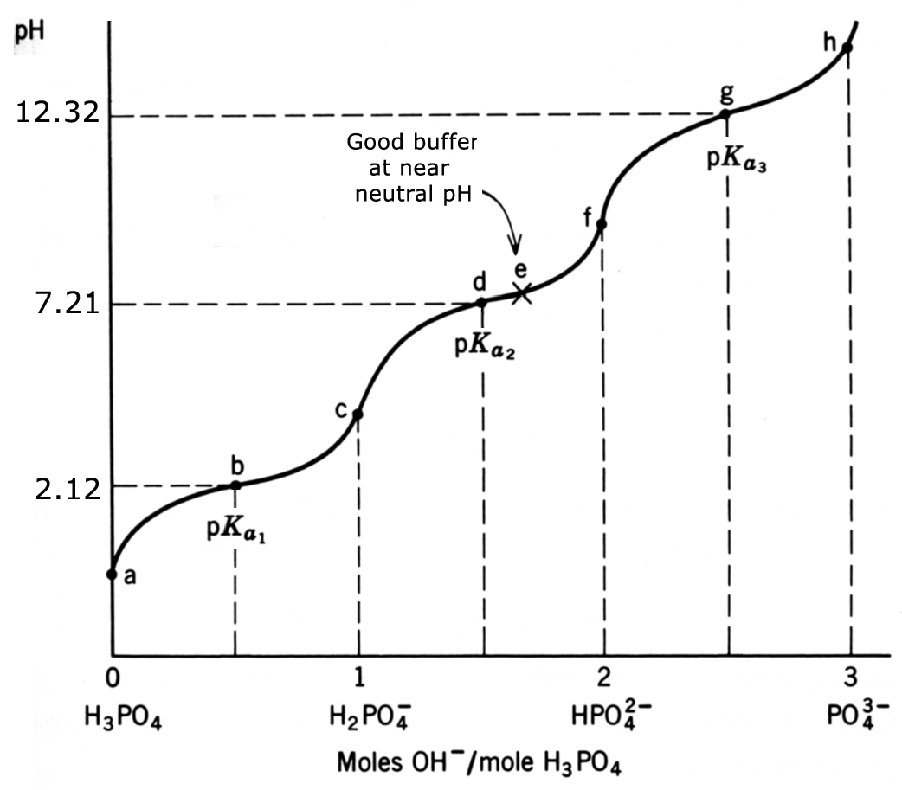

**Fig. 6.** Titration of phosphoric acid, a multiprotic molecule, with a strong base. The initial point, where 100% of the H3PO4 molecules are not ionized, is indicated by **a**. Equivalence points for each ionizable group are indicated by **c**, **f**. and **h**. (Adapted from Siegel, 1976.)

**Multiprotic buffers**

Many laboratory buffers are multiprotic (e.g. phosphoric acid, glycine). Therefore, these buffers have multiple pKa values (cf. Fig. 6), corresponding to the dissociation of protons from each functional group. For phosphoric acid the proton dissociation equations can be written as:

|  |  |  |
| --- | --- | --- |
| H3PO4 ⇌ H2PO + H+ |  | pKa1 = 2.12 |
| H2PO ⇌ HPO + H+ |  | pKa2 = 7.21 |
| HPO ⇌ PO + H+ |  | pKa3 = 12.32 |

To use the Henderson-Hasselbalch equation with multiprotic buffers, one must select the pKa and the corresponding dissociation equation that is closest to the desired pH of the solution.

**Examples**

1. Acetic acid (CH3COOH) has a pKa of 4.8. How many mL of 0.1 M acetic acid and 0.1 M sodium acetate (CH3COO–Na+) are required to prepare 1 liter of 0.1 M acetate buffer, pH 5.8?[4]

Substitute the values for the pKa and the desired pH into equation 10:

|  |  |  |
| --- | --- | --- |
| 5.8 = | 4.8 + log | [CH3COO–] |
| [CH3COOH] |

Solve for the ratio of acetate to acetic acid:

|  |  |  |
| --- | --- | --- |
| log | [CH3COO–] | = 5.8 – 4.8 = 1.0 |
| [CH3COOH] |

|  |  |
| --- | --- |
| [CH3COO–] | = antilog 1 = 10 |
| [CH3COOH] |
| ∴ [CH3COO–] = 10 [CH3COOH] | |

For each volume of acetic acid, 10 volumes of acetate must be added (making a total of 11 volumes of the two ionic species). Multiply the proportion of each component by the desired volume (in this case, 1000 mL) and mix:

0.1 M CH3COOHneeded:     1/11 (1000 mL) =      91 mL

0.1 M CH3COO–Na+ needed:   10/11 (1000 mL) =    909 mL

1,000 mL

Note that when the ratio of [A–] to [HA] is 10:1, the pH is exactly one unit above the pKa. If the ratio were 1:10, the pH would be one unit below the pKa.

2. Calculate mL of glacial acetic acid (17.6 N; assume 99.7% purity)[5] and g of sodium acetate (f.w. = 82 g/mole) that is required to make 100 ml of 0.2 M buffer at pH 3.9.

Again, substituting in equation 10 with the desired pH:

|  |  |  |
| --- | --- | --- |
| 3.9 = | 4.8 + log | [CH3COO–] |
| [CH3COOH] |

Let [CH3COOH] = *x1* mole/L, then [CH3COO–] = (0.2 – *x1*) mole/L

Therefore, pH = pKa + log (0.2 – *x1*/ *x1*) and 3.9 = 4.8 + log (0.2 – *x1*/ *x1*)   
∴ –0.9 = log (0.2 - *x1*/ *x1*) and *x1* = 0.178 mole/L = [CH3COOH]

The concentration of acetate ion can be found from the equation:

moles of CH3COOH/L + moles of CH3COO–/L= 0.2 moles/L   
or *x1 +x2* = 0.2 mole/L. where *x2* represents moles/L of CH3COO–.

This expression indicates that [acid] and [conjugated base] must account for the final concentration of the buffering chemical species in the solution.

Because concentrations are not additive, the number of moles for acid and conjugated base are added instead, but relative to a volume (i.e. per liter). Also, recall that 1 mole/L = f.w. (g)/L and, for monoprotic acids, 1M = 1N.

From the equation above:

0.178 mole/L + *x2* = 0.2 mole/L

∴ *x2* = 0.2 mole/L – 0.178 mole/L 🡪 *x2* = 0.022 mole/L of [CH3COO–]

For 100 mL of solution:

0.1 L X 0.178 mole/L (L/17.6 mole) = 0.00101 L = **1.01 mL of CH3COOH**

and 0.1 L X 0.022 mole/L X 82 g/mole = **0.18 g CH3COONa**

Mix the above in ~25 mL of water and bring to volume to 100 mL in a volumetric flask.

3. Calculate the pH of a solution that was prepared by dissolving 1.83 g of KH2PO4 (anhydrous; f.w. = 136) and 1.16 g of K2HPO4 (anhydrous; f.w. = 174) in 0.2 L of water.

Solution: The applicable dissociation equation for this solution corresponds to pKa2 = 7.21 (see Fig. 4). Therefore:

|  |  |  |
| --- | --- | --- |
| pH = | pKa2 + log | [K2HPO4] |
| [KH2PO4] |

[K2HPO4] = 1.16 g X mole/174 g X 1/0.2 L = 0.033 M

[KH2PO4] = 1.83 g X mole/136 g X 1/0.2 L = 0.067 M

pH = 7.21 + log (0.033/0.067) ∴ pH = 6.92

4. The pH of a sample of arterial blood is 7.42. Upon acidification of 10 mL of the blood, 5.91 mL of CO2, corrected for standard temperature and pressure (S.T.P.), are produced. Calculate (a) the total concentration of dissolved CO2 in the blood [CO2 + HCO], (b) the concentration of dissolved CO2 and HCO, and (c) the partial pressure of the dissolved CO2 (in mm Hg).

(a) First, calculate the number of moles of CO2 represented by 5.91 mL at S.T.P. One mole of a “perfect gas” occupies 22.4 L at S.T.P.; for CO2, the experimental value is 22.26 L.

|  |  |  |
| --- | --- | --- |
| ∴ | 5.91 X 10-3 L | = 26.5 X 10-5 moles of CO2 |
| 22.6 L/mole |

This amount of CO2 came from 10 mL (0.01 L = 1 X 10-2 L) of blood

|  |  |  |
| --- | --- | --- |
| ∴ concentration of “total CO2” = | 26.5 X 10-5moles | **= 2.65 X 10-2 M** |
| 1 X 10-2 L |

(b)

|  |  |
| --- | --- |
| pH = *Ka1*+ log | [HCO] |
| [CO2] |

|  |  |  |  |  |
| --- | --- | --- | --- | --- |
| 7.42 = 6.1 + log | [HCO] |  | 1.32 = log | [HCO] |
| [CO2] | [CO2] |

|  |  |  |
| --- | --- | --- |
| [HCO] | = antilog 1.32 = 20.89 = | 20.89 |
| [CO2] | 1 |

|  |  |  |
| --- | --- | --- |
| [HCO] = | 20.89 | X 2.65 X 10-2 M = **2.53 X 10-2 M** |
| 21.89 |

|  |  |  |
| --- | --- | --- |
| [CO2] = | 1 | X 2.65 X 10-2 M = **1.21 X 10-3 M** |
| 21.89 |

(c) [CO2]dissolved = *k* (*P*CO2) mm Hg

|  |  |  |  |  |  |
| --- | --- | --- | --- | --- | --- |
|  | *P*CO2= | [HCO] | = | 1.21 X 10-3 | = **40.22 mm Hg** |
| [CO2] | 3.01 X 10-5 |

**Experimental Procedure**

1. Prepare 100 mL of 0.3 M phosphate buffer, pH 7.5. Start with solid Na2HPO4 and KH2PO4 and diH2O. Use the Henderson-Hasselbalch equation to calculate the number of moles/100 mL of each phosphate salt that you need to prepare the solution. Convert the molar amount to g using the formula weight given on the chemical containers and weigh out the appropriate amount of each component on the balance.
2. Set up a 100 mL beaker on a stir plate. Add 80 mL of diH2O[6] and a stir bar and start stirring the liquid. Dissolve the solid phosphate salts by slowly adding each powder to the beaker. Allow the solid to dissolve completely. When they are dissolved, adjust the volume to 100 mL using a 100 ml graduated cylinder (Erlenmeyer flasks and beakers have less accurate volumes than cylinders).
3. Transfer the solution back to the beaker and measure the pH of the solution using the pH-meter. Does it agree with the desired pH of 7.5? If not, can you explain why?
4. One of the most common buffers used in experimental biology is called phosphate buffered saline (PBS). There are many formulations for PBS. For example: weigh 8 g sodium chloride (NaCl), 0.2 g potassium chloride (KCl), 2.17 g sodium phosphate dibasic (Na2HPO4)[7], 0.2 g potassium phosphate monobasic (KH2PO4); dissolve in 80 mL of diH2O. Measure the pH using; adjust pH to 7.5 if necessary and add dH2O to 100 mL. What are the final concentrations of each ion in your PBS?

[PO] =         mM [Na+] =         mM    [K+] =         mM    [Cl–] =         mM

**Questionnaire**

**Lab 3. Preparation of a phosphate buffer.**

1. Your lab manual contains a deduction of the Henderson-Hasselbalch equation using the dissociation of a weak acid, HA, to its conjugate base (A–) and a H+. Use the dissociation of a weak base to estimate pH (yes, pH) of a weak base in solution using the parameter pKb.

BOH ⇆ B+ + OH–

where BOH = a weak base. Start by describing the degree of dissociation of BOH into OH– and B+ using Kb. Hint: pOH = –log [OH–]

1. Describe, stepwise, how you would prepare 0.5 L of a 0.15 M phosphate buffer, pH 12.5, using K3PO4·H2O (f.w. = 230.28) and K2HPO4 (f.w. = 174.18).

Assume that after dissolving the salts your pH-meter reading is 11.9.

1. What is the enzyme that catalyzes the reaction CO2 + H2O ⇌ H2CO3 in human tissues, including blood?
2. Since this reaction takes place in the absence of the enzyme, what is the physiological advantage in having such enzyme in the blood? [Hint: find what the turnover number is for this enzyme.]
3. This enzyme is also found in chloroplasts. What do you think the role of this enzyme is in plants?

1. Siegel IH (1976) Biochemical Calculations, 2nd Edition, John Wiley & Sons, pp. 83-86.
2. Horton HR, Moran LA, Ochs RS, Rawn JD, Scrimgeour KG (2002) Principles of Biochemistry, 3rd edition, Prentice-Hall, Upper Saddle River, NJ, p. 41.
3. You have to keep in mind that protons go into solution every time each one of these chemical species dissociates.
4. Source: Horton et al., 2002, op. cit., pp. 38-42.
5. Other important information for CH3COOH: f.w. (formula weight) = 60.05 g/mole;  = 1.05 g/cm3.
6. diH2O = deionized water; dH2O = distilled water, ddH2O = double-distilled water
7. Phosphate salts might contain chemically-bound water (v.g., monohydrate, dihydrate, etc.). You must factor in water molecule number in the formula weight if not specified on the container.