Related Links: Leadership Vs Management | Leadership Power | Management Styles Quiz | Management Styles Powerpoint Presentation
Introduction. Select and investigate a New Zealand business leader practicing diversity (with a diverse workforce) as well as ethics and corporate social responsibility. The organisations could be a profit, non-profit, private, publicly-traded, or public entity. The leader should be currently part of the organisation and could be from any level of organisational hierarchy: lower leveleader such as a team leader, a mid-level manager such as a department head or a top-level executive such as a CEO. The selected leader will be having at least 3 direct reports or supervise 3 staff members.
leader such as a team leader, a mid-level manager such as a department head or a top-level executive such as a CEO. The selected leader will be having at least 3 direct reports or supervise 3 staff members.
In management text books the three most talked about management styles are democratic, autocratic and consultative. Selecting the correct management style will often lead to greater motivation and productivity from your staff. However, it is not as easy as just 'picking' a style. Managers personalities and characteristics will influence the type of style adopted. For example a timid manager will find an autocratic management style difficult to adopt.
Democratic Management Style
A democratic manager delegates authority to his/her staff, giving them responsibility to complete the task given to them (also known as empowerment). Staff will complete the tasks using their own work methods. However, the task must be completed on time. Employees are involved in decision making giving them a sense of belonging and motivation. As staff feel a sense of belonging and motivation ted the quality of decision making and work is likely to be high. Although popular in business today, a democratic management style can slow decision making down because staff need to be consulted. Also some employees may take advantage of the fact that their manager is democratic by not working to their full potential and allowing other group members to 'carry' them.
Autocratic Management Style
In contrast to a democratic management style, an autocratic manager dictates orders to their staff and makes decisions without any consultation. Autocratic managers like to control the situation they are in. Decision are quick because staff are not consulted and work is usually completed on time. However this type of management style can decrease motivation and increase staff turnover because staff are not consulted and may not feel valued.

Consultative Management Style
A consultative management style can be viewed as a combination of democratic and autocratic. The consultative manager will ask views and opinions from their staff, allowing them to feel involved but will ultimately make the final decision.
Laissez Faire Management Style
A laissez faire manager sets the tasks and gives staff complete freedom to complete the task as they see fit. There is minimal involvement from the manager. The manager however does not sit idle and watch them work! He or she is there to coach or answer questions, supply information if required. The benefits of a laissez faire management style is that giving staff personal responsibility for tasks, aids their development and can lead to improved motivation and staff confidence. However the danger is that a laissez fair style manager who does not provide adequate direct guidance may have staff who feel lost and staff who do not reach their objectives and meet deadlines.
Diagram: Different Forms of Management Style
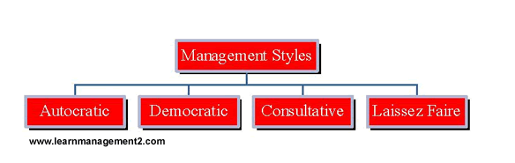
Conclusion
In this article we have covered four management styles; autocratic, democratic, consultative and laissez faire. Each of the four management styles has its advantages and disadvantages. The most appropriate management style for a manager and his direct reports will depend on the work, the manager's personality and the experience and skills of the workforce. Inexperienced staff need direction and will not have the experience to participate in the consultation style of a consultative or laissez faire manager. However highly qualified or skilled employees will not appreciate being told how to do things by an autocratic manager.

