Aim: To consolidate and apply learning about the working of the extended trial balance

Please review the extended trial balance below carefully; it is the table that you considered in the previous activity. Make sure you understand what it shows.

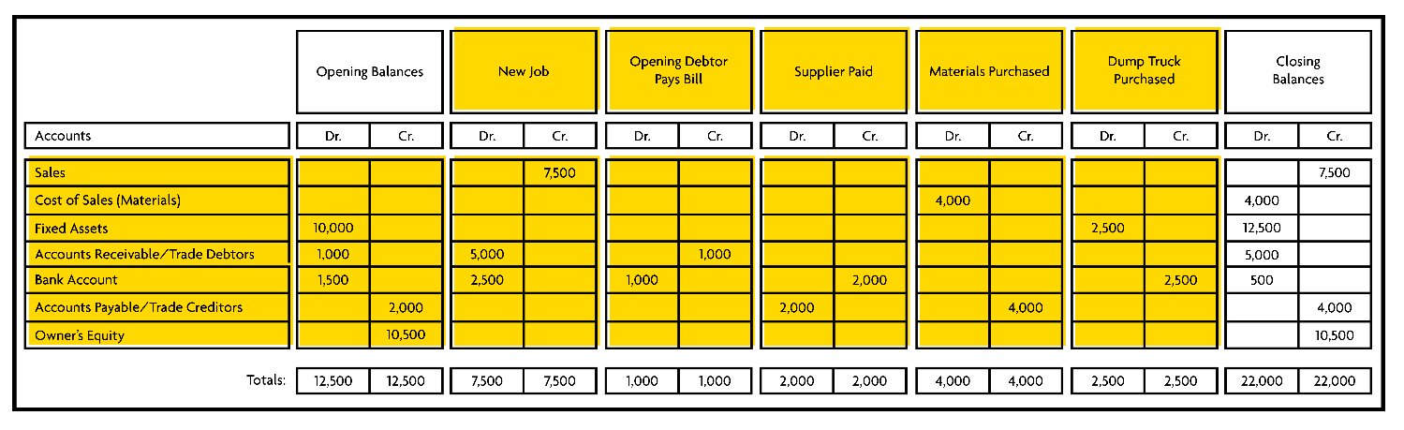
Next, try doing the following examples yourself.

TASK One
A startup business approaches a building company to build a newspaper kiosk. The building company agrees to undertake the project for £7,500.
The startup business cannot pay right away, as their overdraft limit is £2,500. The startup business is allowed to use this as a down payment for the work to be done.
The startup buys £1,500 worth of goods for resale, using trade credit, and takes delivery of £300 worth of newspapers, also on credit.
On the first day of trading, the startup business takes £2,500 in cash.
At the end of the first day, there is £350 of saleable stock left and only half the newspapers have been sold. The remaining half can be returned to the distributor for a full refund.
Trading follows the same pattern for the following six days. The business takes £2,500 per day, and buys exactly the amount that was used on the first day—always taking trade credit.
At the end of the sixth day, the trade creditors (except for the building company) are paid. The building company is not yet paid as this payment has been postponed until after the end of the period.
Post these entries in the blank extended trial balance and answer the following questions:
- What profit did the startup business make?
- Where did its profit go?

TASK Two
On the spreadsheet template, record the following opening transactions for a small business.
1st January
- The owner puts £10,000 in the business bank account.
- The business pays the first two months’ rent on shop premises: £5,000.
3rd January
- The business buys a display counter for £3,000. This is expected to last for 24 months.
- £4,000 worth of inventory (stock) for resale is paid for by cheque.
5th January
- £2,000 worth of inventory is bought on credit.
8th January
- The shop opens for business.
14th January
- £3,000 is taken from the till and banked.
21st January
- £2,500 is taken from the till and banked.
22nd January
- A reliable customer comes in and buys £500 worth of goods, promising to pay you next month.
24th January
- The owner takes £1,000 in cash from the till for their own use.
30th January
- The part time assistant is paid £1,500.
31st January
- £4,000 is taken from the till and banked.
- The owner does an inventory check prior to re-stocking, and finds that there is £1,500 worth of saleable inventory left on the shelves.
An electricity bill for £900 for the period 1st January to 31st March is expected in April.
As well as the transactions shown above, work out the following:
- Is a depreciation charge required?
- Will there be any accrued expenses at the month end?
- Will there be any prepaid expenses at the month end?

Post entries in your extended trial balance to record what is required here. Once you have recorded these, and are satisfied with the resulting trial balance, post a final entry to write off the income statement balances to the profit and loss reserve. The spreadsheet should automatically calculate the totals for you. Make sure the debit and credit columns of each transaction add up to the same amount.
You can use the attached templates in Microsoft Excel, OpenOffice, or Google Docs. You may prefer to create your own or to write it out by hand. It is up to you how you present your extended trial balance.

Upload both of your completed extended trial balances to the Tutorial area along with the answers to the questions and an explanation of how you reached your conclusions.
TASK 3
You should include a short report 100 words outlining any difficulties you faced or any concerns you have to identify where feedback would be most helpful.

