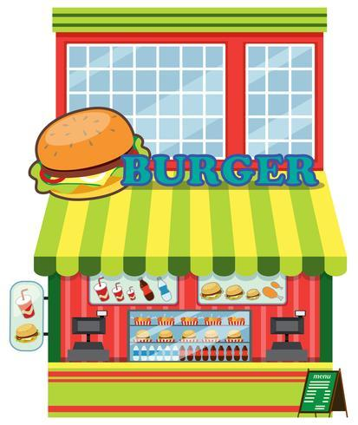
The Bureaucracy of A Burger PLACE

Taking a Closer Look at How the Federal Bureaucracy Governs Your Burgers!

1789 the State Department had 9 employees, the War Department had 2, and the Treasury Department had 39. Today, the State Department employs about 32,000 civilians, the Defense Department about 760,000, and the Treasury Department about 108,000. The federal bureaucracy today boasts 15 Cabinet departments and dozens of agencies, regulatory commissions, and government corporations, with a civilian workforce of more than 2.8 million. The bureaucratic behemoth exercises power and influence over virtually every facet of the nation’s social and economic life. In the view of many observers, the power, reach, and independence of the federal bureaucracy demand that it be viewed as a fourth branch of government.

Directions: Your task is to take each component of a taco truck and, using the links below, research the federal agencies and departments that would regulate it in some way. Use the chart on the next page to explain how each component of the taco truck is regulated by the agency and/or department. Your answers may be typed but must be IN YOUR OWN WORDS (DON’T SIMPLY CUT AND PASTE)

Internet Resources:
The links below will assist you in determining how each federal agency and/or department regulates each taco truck component:

- Restaurant Regulations
  - COMPLETED FOR YOU AS AN EXAMPLE ON THE NEXT PAGE
- Buns
  - https://www.ams.usda.gov/sites/default/files/media/CID%20Rolls%2C%20Bread%2C%20Fresh%20or%20Frozen.pdf
- Burger Meat
  - https://www.ams.usda.gov/sites/default/files/media/CID%20Beef%20Patty%20Products%2C%20Fully%20Cooked%2C%20Individually%20Quick%20Frozen.pdf
- Lettuce
  - https://www.fda.gov/downloads/Food/GuidanceRegulation/UCM169008.pdf
- Tomato
  - https://www.ams.usda.gov/grades-standards/tomato-grades-and-standards
- Cheese
  - https://www.ams.usda.gov/grades-standards/bulk-american-cheese-grades-and-standards
- Ketchup
  - https://www.today.com/food/what-fancy-ketchup-it-actually-better-regular-ketchup-t144019
  - https://www.ams.usda.gov/grades-standards/tomato-catsup-grades-and-standards
- Fries
  - https://www.ams.usda.gov/grades-standards/frozen-french-fried-potatoes-grades-and-standards
- Milkshakes
  - https://www.ams.usda.gov/grades-standards/ice-cream
  - https://www.accessdata.fda.gov/scripts/cdrh/cfdocs/cfcfr/CFRSearch.cfm?fr=135.110
  - https://mymarketnews.ams.usda.gov/mars-faqs/what-are-milk-classes-under-federal-milk-order-system

Ingredients
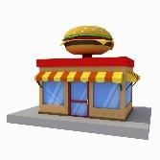  Restaurant Regulations | Department/Organization: Food and Drug Administration (FDA)  Regulatory Oversight: Regulations and permits; food safety and inspection; food handling, preparation, and storage
Buns | Department/Organization: ___________________________________________________  Regulatory Oversight:
Burger Meat | Department/Organization: ___________________________________________________  Regulatory Oversight:
Lettuce  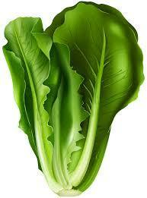 | Department/Organization: ___________________________________________________  Regulatory Oversight:
Tomato | Department/Organization: ___________________________________________________  Regulatory Oversight:
Cheese | Department/Organization: ___________________________________________________  Regulatory Oversight:
Ketchup | Department/Organization: ___________________________________________________  Regulatory Oversight:
French Fries | Department/Organization: ___________________________________________________  Regulatory Oversight:
Milkshakes | Department/Organization: ___________________________________________________  Regulatory Oversight:
Questions to Answer
- What generalizations can you make about the “bureaucracy of a burger place,” i.e. how involved are federal agencies and departments in the burgers that you eat?

- What are the advantages and disadvantages to consumers of burger (like you) of federal rules and regulations? Advantages and disadvantages for burger businesses? Bullet point your answers.
Consumers

Advantages | Disadvantages

Burger Restaurant Businesses

Advantages | Disadvantages

- Based on what you learned from this activity about the bureaucracy of a burger, would you go into the burger restaurant business? Why or why not?

