2.1 Theories and Studies Related to Social Trust
-Social Capital Theory (1 page of writing about how the theory related to social trust)
-Reasoned Action Theory (1 page of writing about how the theory related to social trust)

Theoretical Framework
(2 pages of explanation about this theoretical framework)
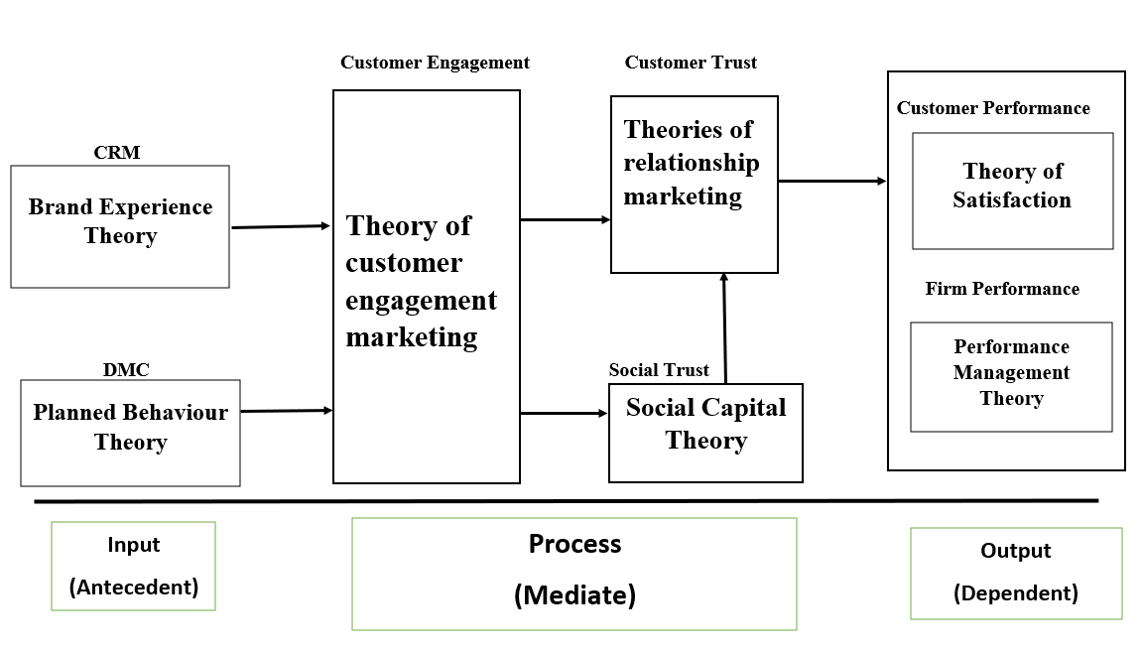

Conceptual Framework (2 pages of explanation about this conceptual framework)
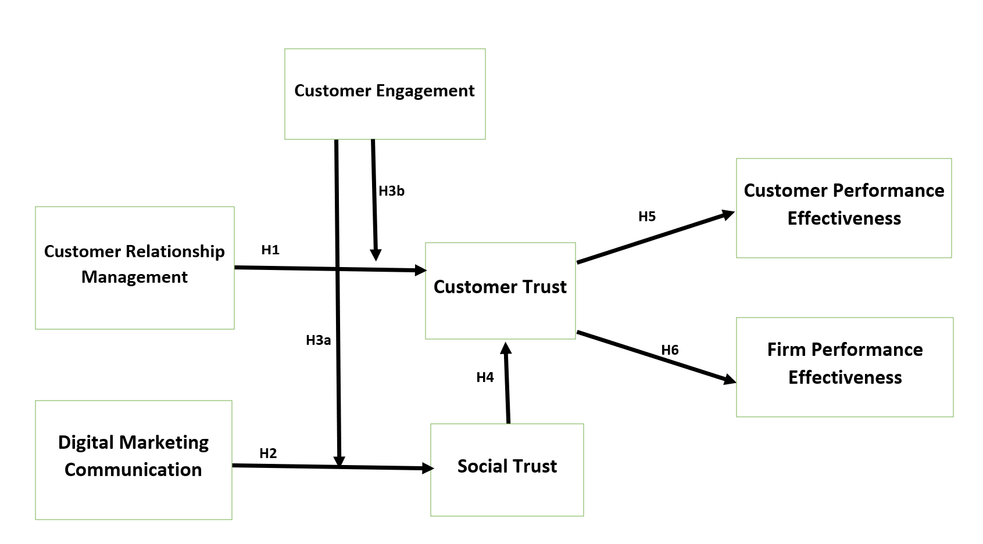

H4: Social trust has a positive influence on customer trust (2 pages of explanation about H4)

