BCO315 Corporate Finance Task brief & rubrics
Task: Final Assignment (60% of course grade)
You are asked to answer all the questions in the proposed four cases.
This task assesses the following learning outcomes:
- Discuss and analyze the benefits of leasing versus ownership of assets.
- Analyze the concepts underlying the firm’s cost of capital.
- Demonstrate a deep understanding of the theory and practices of mergers and acquisitions.
- Critically evaluate financial distress.
LAUNCH: WEEK 5 / DELIVERY: WEEK 8 Sunday July 19th, 2020, 23:59hrs ON MOODLE
Submission file format: Word document with all the answers, clearly identifying each case separately.

CASE 1 (20 points)
You work for a nuclear research laboratory that is contemplating leasing a diagnostic scanner (leasing is a very common practice with expensive, high-tech equipment). The scanner costs €4,800,000, and it would be depreciated straight-line to zero over four years. Because of radiation contamination, it actually will be completely valueless in four years. You can lease it for €1,430,000 per year for four years. You can borrow at 8 percent before taxes. Assume that the tax rate is 21 percent.
Instructions:

- Create a lease-versus-buy analysis. Calculate the NPV of leasing. Should you lease or buy? (10 points)

- What are the differences between an operating lease and a financial lease? (10 points)

CASE 2 (30 points)
Suppose stock in Warren Corporation has a beta of 0.80. The market risk premium is 6 percent, and the risk-free rate is 6 percent. Warren’s last dividend was €1.20 per share, and the dividend is expected to grow at 8 percent indefinitely. The stock currently sells for €45 per share. Warren has a target debt-equity ratio of 0.50. Its cost of debt is 9 percent before taxes. Its tax rate is 21 percent.

Instructions:

- What is Warren’s cost of equity capital? Assume that you equally believe in the CAPM approach and the dividend growth model. (5 points)

- What is Warren’s WACC? (5 points)

- Warren is seeking €30 million for a new project. The necessary funds will have to be raised externally. Warren’s flotation costs for selling debt and equity are 2 percent and 16 percent, respectively. If flotation costs are considered, what is the true cost of the new project? (10 points)

- Under what circumstances would it be appropriate for Warren Corporation to use different costs of capital for its different operating divisions? What are two techniques you could use to develop a rough estimate for each division’s cost of capital? (10 points)

CASE 3 (25 points)
Penn Corporation is analysing the possible acquisition of Teller Company. There are two alternatives for Penn: to use cash or stock as payment. Both firms have no debt. Penn believes the acquisition will increase its total after-tax annual cash flow by €1.3 million indefinitely. The current market value of Teller is €27 million, and that of Penn is €62 million. The appropriate discount rate for the incremental cash flows is 11 percent. Penn is trying to decide whether it should offer 35 percent of its stock or €37 million in cash to Teller’s shareholders.
Instructions:

- What is the cost of each alternative? (5 points)

- What is the NPV of each alternative? (5 points)

- Which alternative should Penn choose? (5 points)

- What are some important factors in deciding whether to use stock or cash in an acquisition? (5 points)

- Explain what defensive tactics the managers of Teller Company could use to resist acquisition. (5 points)

CASE 4 (25 points)
Nancy Corporation is suffering from financial distress as it can be seen from its balance sheet:
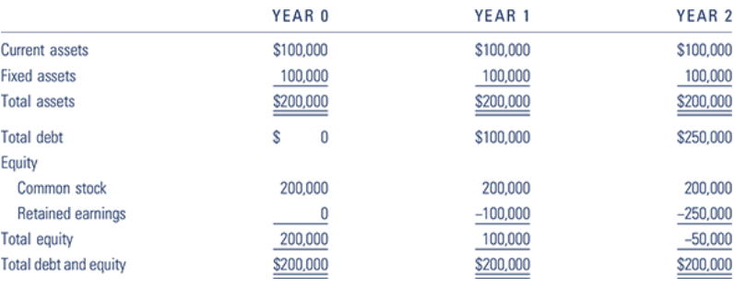
Two scenarios are possible for Nancy in Year 3:
In scenario 1, Year 3 for Nancy is expected to result in an additional $150,000 operating loss.
In scenario 2, Year 3 is expected to be a “breakout” year for Nancy when higher sales and lower costs owing to economies of scale are forecasted to produce operating profits of $250,000 in Year 3.
Total assets are expected to remain at $200,000 under either scenario. Total debt will be increased to finance additional operating losses. Operating profits will be used to reduce total debt.
Instructions:

- Show Nancy’s balance sheets under both scenarios. (10 points)

- Based on your analysis, will Nancy Corporation still be balance sheet insolvent in Year 3 under scenario 1? If this trend continues, would you describe Nancy’s financial distress as a temporary or a permanent problem? (5 points)

- Based on your analysis, will Nancy Corporation still be balance sheet insolvent in Year 3 under scenario 2? If this trend continues, would you describe Nancy’s financial distress as a temporary or a permanent problem? (5 points)

- There are two basic options in the situation of financial distress: liquidation or reorganization. Explain them. (5 points)

Rubrics
 | Descriptor
9-10 | The student demonstrates an excellent understanding of the concepts.
8-8.9 | The student demonstrates a good understanding of the concepts.
7-7.9 | The student demonstrates a fair understanding of the concepts.
6-6.9 | The student demonstrates some, but insufficient understanding of the concepts.
3-5.9 | The student demonstrates insufficient understanding of the concepts. They may mention some relevant ideas or concepts, although it is clear that the relationship between them is not understood by the student.
1-2.9 | The student demonstrates insufficient understanding of the concepts and does not mention any relevant ideas or concepts.
0 | The student leaves the question blank or cheats.

Points are stated at the end of each question.

