PART A – Reflecting on the child’s responses
Write a report, using the template (below), about each child’s mathematical understanding. 500 words (250 per child)

- Imagine you are writing a report for the child’s teacher.

Use technical terms like “conservation of number” or “forward counting sequences”

- Include notes taken during the interview

- Make links to the Early Years Learning Framework and or the NSW NESA mathematics curriculum

The Report to the child’s teacher Template
Child A or B (circle) pseudonym: Mila
SENA administer (circle): SENA 1 or SENA 2
Grade of child: Kindergarten
Planning the letter to the child’s teacher (use dot points):
What can the child do? | What areas require further development? | Prove what you are saying by referring to the EYLF and/or syllabus
-visual counting  -subitising | -numeral identification on larger numbers  -forward number word sequence  -backward number word sequences after 10  -counting without counters | (fill in)

Write the letter to the classroom teacher in 250 words per child:

The Report to the child’s teacher Template
Child A or B (circle) pseudonym: Oliver
SENA administer (circle): SENA 1 or SENA 2
Grade of child: Year 2
Planning the letter to the child’s teacher (use dot points):
What can the child do? | What areas require further development? | Prove what you are saying by referring to the EYLF and/or syllabus
-Numeral identification  -Addition and subtraction  - counting by 10s and 100s  -place value  -multiplication and division  -area multiplication | -Knows the answer but has trouble explaining how he got the answer  -when combining and partitioning using more combinations than just 10+0, 0+10 and using more complex e.g. 4+6 | (fill in)

Write the letter to the classroom teacher in 250 words per child:

PART B
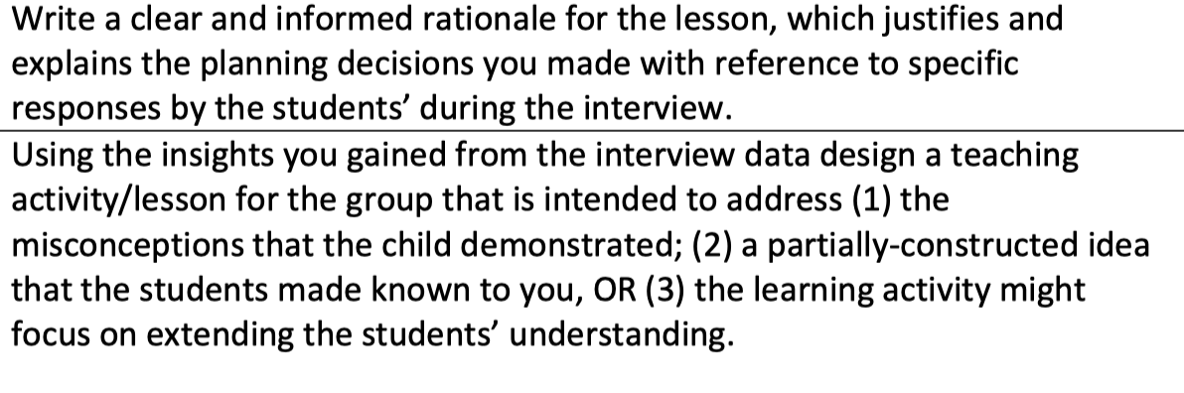1.

2.

Lesson plan format (just fill in the boxes)
Lesson Plan – Student A (Mila)
LEARNING EXPERIENCES (LESSONS) TEMPLATE – FOR ASSESSMENT 1

Class/Group: Kindergarten |  | Date: 25.04.2020 |  | Time: 9.45  Start: 9.45  Finish:10.45
Key Learning Area (Subject): Mathematics |  | Lesson Topic:
Rationale for the lessons: (Remember you have selected 1 child that you interviewed and your lessons are for a group of students (approximately 8) that are at the same level as your child). Add name of child here and the SENA that you used:
Key Objective and level: (selected from the NSW K-10 syllabuses)

Syllabus outcomes:  Content strand:  Sub-strand(s):  Content Outcome:  Working Mathematically Outcomes: | Indicators of Learning/Content for this lesson:  Behaviours that contribute toward achievement of Learning Outcomes. Quote intention codes. Must be clear, specific, observable.  By the end of this lesson, the students will:  -  -  - |  | Assessment:  Strategies which will be used to assess learners’ attainment of learning outcomes. Should be linked to each Indicators of Learning/Content  -  -  -  -
Key mathematical technical language (be specific and include definitions of key words appropriate to use with students):

Resources:
List resources you used in preparing the lesson AND those used in the lesson implementation.
LESSON SEQUENCE
Lesson Content /Indicators of Learning (What is Taught): | Timing  60 (mins) | Teaching Strategies / Learning Experiences:  (How it is taught)  Write detailed steps showing what the teacher (T) will do and what students (Ss) will do. | Resources and Organisation:
MATHEMATICAL
FOCUS
(what you want the children to come to understand because of this lesson – short, succinct statement)
INTRODUCTION
‘LAUNCH’
Focus on Mental Warm Ups
Review known and explore new skills and understandings across all strands
‘INTRODUCE’
Share learning intentions
Share learning outcomes
Provide students with an overview of the concept/ content
DEVELOPMENT
‘EXPLORE’
Small group/ whole class / individual focus
Teacher works with a focused group / rove / work with a support group
CLOSURE
‘SUMMARISE/ REVIEW’
Encourage students to reflect on their mathematical thinking
Share highlights
Discuss problems
Summarise key ideas
Share the learning journey - where to next?

Criteria
