Executive Summary
This report is an integrative assignment of the Corporate Award Program module five, focusing on the procurement and supply function at the Nigeria Republic Basic Industries Corporation (NRPCO). It begins by introducing NRPCO Corporation structure and corporate functions, as well as addressing the relationship between procurement, and NRPCO’s manufacturing affiliates. The report defines three commodities of expenditure at NRPCO, and focuses on direct materials commodity. Examine this commodity will develop a sourcing plan, defining the role of procurement and supply in managing expenditures within direct materials, and explain the correlation between the direct materials consumption plan and production forecast. The report will underline the inputs made by stakeholders through classifying their engagement with a sourcing plan based on their level of interest and power to contribute. Further, it will outline techniques for adding value to this type of expenditure, through McKinney 7S Framework to restructure organization, and in classifying purchasing categories based on two main factors of the Kraljic Matrix, the importance of the purchase and the complexity of the supply market. Additionally, the report will cover inclusions such as material specification that should be made in future contracts, a four-step measures to select effective suppliers, and aspects of purchase or supply that may require negotiation through four strategies.

Introduction NRPCO Overview
Oil and gas are two of the most important natural resources powering the world with energy. Downstream in the supply chain, they also serve as raw materials for the petrochemical plants in which hundreds of thousands of finished goods and products are manufactured. One of the world’s leading corporations in the petrochemical field is the Nigeria Republic Basic Industries Corporation (NRPCO). NRPCO aims to be a world leader among chemical corporations, managing production lines for chemicals, fertilizers, plastics, and metals through 68 manufacturing affiliates in 50 countries around the world. One of the main factors that keeps NRPCO profitable, strong, and competitive in the petrochemical field is the four strategic roadmap to realize its vision: increase flexibility through local and global access to oil and gas feedstock, select leading technologies in line with the most up-to-date industry best practices, differentiate company services in the global market to offer high value-added innovative products, and grow company revenue through world-class financial performance.
While corporate finance focuses on financial status, and effective marketing intelligence focuses on increased sales and revenue, the procurement and supply functions within NRPCO both focus on sourcing plans and production support, and both play major roles in decreasing the costs of final products (NRPCO 2019 Annual Report).
Corporate Structure, Corporate Functions, and Incorporated Affiliates
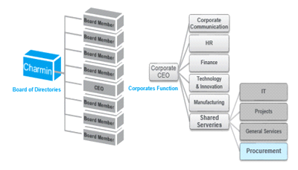
As shown on above structure, NRPCO Board of Directors includes nine members: Charmin, the CEO, and seven board members. NRPCO corporate function is comprised of six component functions, including the Shared Services function, which aims in part to provide procurement services to NRPCO’s 68 manufacturing affiliates. While many NRPCO functions look to Procurement as a provider of services, affiliates evaluate Procurement more than a services provider to an end-user. (NRPCO 2019 Annual Report)
Procurement Services, Manufacturing Affiliates, and Commodities of Expenditure
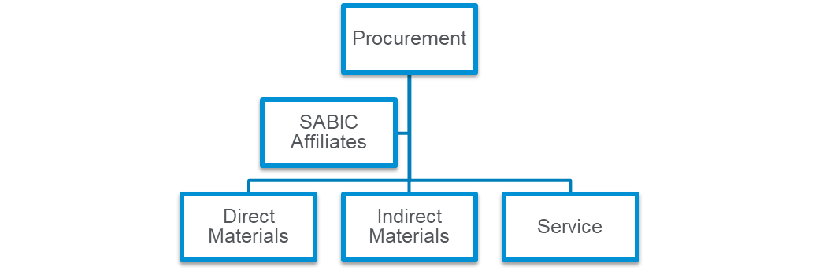
The relationship between Procurement and NRPCO’s manufacturing affiliates is crucial to the company’s operations and production. Procurement at NRPCO purchases three main commodities. The first commodity is direct materials, which includes feedstock, water treatment, processing chemicals, additives, catalysts, and packaging. The second commodity is indirect materials, such as spare parts and tools for operation and maintenance. The third and final commodity is services, including shipping, logistics, expediting, customs duties, inventory control, and mapping the location of materials at NRPCO affiliate warehouses. Therefore, developing sourcing plan and procurement of supplies is important to managing expenditures and will be reflected in the cost of NRPCO’s final products. Walking through Procurement’s procedures and policies for the three above-mentioned categories, identifying ways to strengthen coordination, analyze obstacles, and improve the service’s efficiency for the end-user (NRPCO 2019 Annual Report).
Model 1. The Roles of Procurement and Supply in Managing Expenditures on Direct Materials (With Emphasis on Stakeholder Input)
Walking through Procurement procedures and policies explains how stakeholder input is collected and implemented through the procurement cycle and addresses actions that NRPCO could take to improve procurement service efficiency and manage direct material expenditures effectively through sourcing plan.
Model 1.1. NRPCO Procurement Cycle, Procedures, and Policies

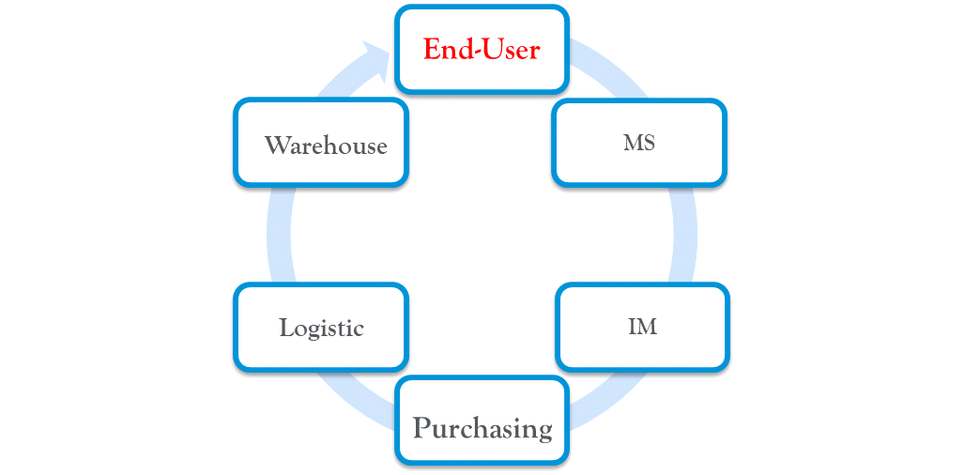
As shown in Model 1.1, NRPCO’s procurement process is a cycle that starts from an end-user, who checks the specifications of the materials they need in the Material Standardization (MS) database and requests an order on the system. The order then is transferred to Inventory Management (IM). An IM planner reviews warehoused materials and either secures the order or issues a Purchase Requisition (PR). If a PR is issued, a buyer searches for sources and will either issue an RFQ for spot buying or issue a direct PO for the contracted item. If a PO is issued, logistics manage to ship from the supplier to the end-user warehouse.
Throughout this cycle, some obstacles may arise, such as out-of-date material specifications on the MS database, pending PRs for quality approval from a laboratory, late international shipments, lost or misplaced materials, high detention costs, and high yard costs. All of these obstacles affect the efficiency of procurement services, causing possible delays in processing requests, maintenance schedules, and production plans, which in turn can lead to losses and high expenditures as the company moves to quickly re-establish a sustainable cycle that meets stakeholders’ expectations. To minimize these obstacles and reduce costs we must first define the application and usage of direct materials throughout the production line.
Model 1.2 Usage and Application of Direct Materials Throughout the Production Line
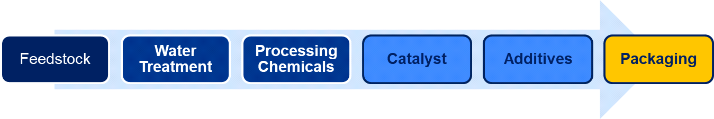
Model 1.2 explains the application and usage of direct materials throughout the production line. Direct materials are processed in six categories, the first of these being the feedstock of chemicals, fertilizers, plastics, and metals. The next categories are water treatment for general and production use, and processing chemicals such as oil and gas downstream products like fuel, and lubricants. The final three categories are catalysts (chemical substances that optimize the production process), additives (substances that add a function or features to final products), and packaging.
The direct materials within each category can be further classed by their attributes, like material group, material class, chemical name, trade name, physical form, size, color, CAS number and packaging type. These attributes, designed by MS, not only help ensure that NRPCO fulfils end-user requirements, but together create a universal metric for comparing the direct materials used between NRPCO’s global affiliates and the global market. With the material group and class, the buyer can specify their purchases according to the end-user ’s requirements, with the chemical name, trade name and CAS number, the buyer can compare alternatives from competitive suppliers or upgraded sources that may be more effective than existing ones. Additionally, the production forecast and the consumption plan for direct materials are correlated. The consumption plan specifies end-user requirements based on the production forecast, the higher the volume to be produced, the higher the volume of direct materials to be consumed. Therefore, an accurate production forecast is a key player in determining the annual consumption plan. It identifies the risks associated with each category and their importance to production, and in doing so, empowers stakeholders at different levels to improve the efficiency of direct material expenditures through strategic sourcing.
Model 1.3. Stakeholder Analysis
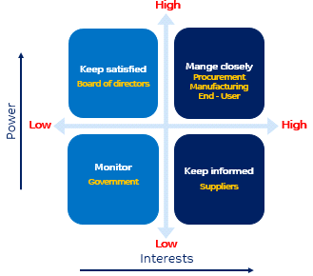
Stakeholder analysis is a method used to classify the engagement of stakeholders with a sourcing plan based on their level of interest and power to contribute. The classifications outline the different levels of stakeholder input, the stakeholders to spend more time with in order to execute successful plans, and the actions that can be taken to improve procurement services and expenditure efficiency through a strategic sourcing plan. (De Mascia 73–74.)
As shown in Model 1.3, both ‘Monitor’ and ‘Keep Satisfied’ stakeholders have relatively low interests on strategic sourcing plan, due to low interest in engagement on the sourcing planning process. However, ‘Keep Satisfied’ stakeholders, namely the members of the Board of Directors, are high in power due to their influence. While ‘Monitor’ stakeholders namely Government actors, do not exert such a high degree of influence on NRPCO and relatively low in power. On the other hand, interest is high for both ‘Manage Closely’ and ‘Keep Informed’ stakeholders, due to their relatively high interest in contributing to the sourcing planning process. Additionally, ‘Manage Closely’ stakeholders are relatively high in power compared to ‘Keep Informed’ stakeholders.
Governments support local business development by capitalizing on local resources and providing opportunities that differentiate sources of income, support the economic cycle, and create more jobs in their jurisdiction. However, due to less direct involvement in procurement businesses in NRPCOs, even active Governments have relatively low power and interests in the creation of NRPCO’s strategic sourcing plan. Therefore, they are classified as ‘Monitor’ stakeholders whose main purpose in this context is to ensure that NRPCO business affiliates are in compliance with commercial law, as well as the relevant environment, health and safety standards.
With NRPCO’s strategic roadmap set forth to realize its vision, the Board of Directors can empower procurement services and strategic sourcing by increasing local and global access to natural resources like oil and gas feedstock, selecting leading technologies, and adapting industry best practices. However, the Board of Directors has little incentive to participate in developing the strategic sourcing plan. Since they have a lot of power and were responsible for implementing the site policies, procedures and KPIs to assure that procurement services would achieve NRPCO’s stated goals, they are classified as stakeholders to ‘Keep Satisfied,’ who expect the best results.
Suppliers are external stakeholders with a high interest in increasing sales and revenue and building strong relationships with customers. This level of interest is reflected in strategic sourcing plans, which will often include their advertising for a promotion or product launch, their participation in industrial conferences, and their engagement with their products quality approval. However, due to their low influence on purchasing decisions, suppliers have relatively low power over the strategic sourcing plan, and as such are classified as stakeholders to ‘Keep Informed.’
The previous section explained the role of direct materials’ attributes, and how buyers can use them to specify end-user requirements and evaluate upgraded sources and alternatives from competitive suppliers. It also covered the correlation between production forecasts and direct material consumption plans. These facts in turn, enable us to classify Procurement, the end-user, and the Manufacturing function as stakeholders to ‘Manage Closely,’ with high interests in and power to influence strategic sourcing plans.
Model 2. The Techniques Can Be Applied To The Area of Expenditure To Improve Add Value.
Model 2.1 McKinsey 7S Framework
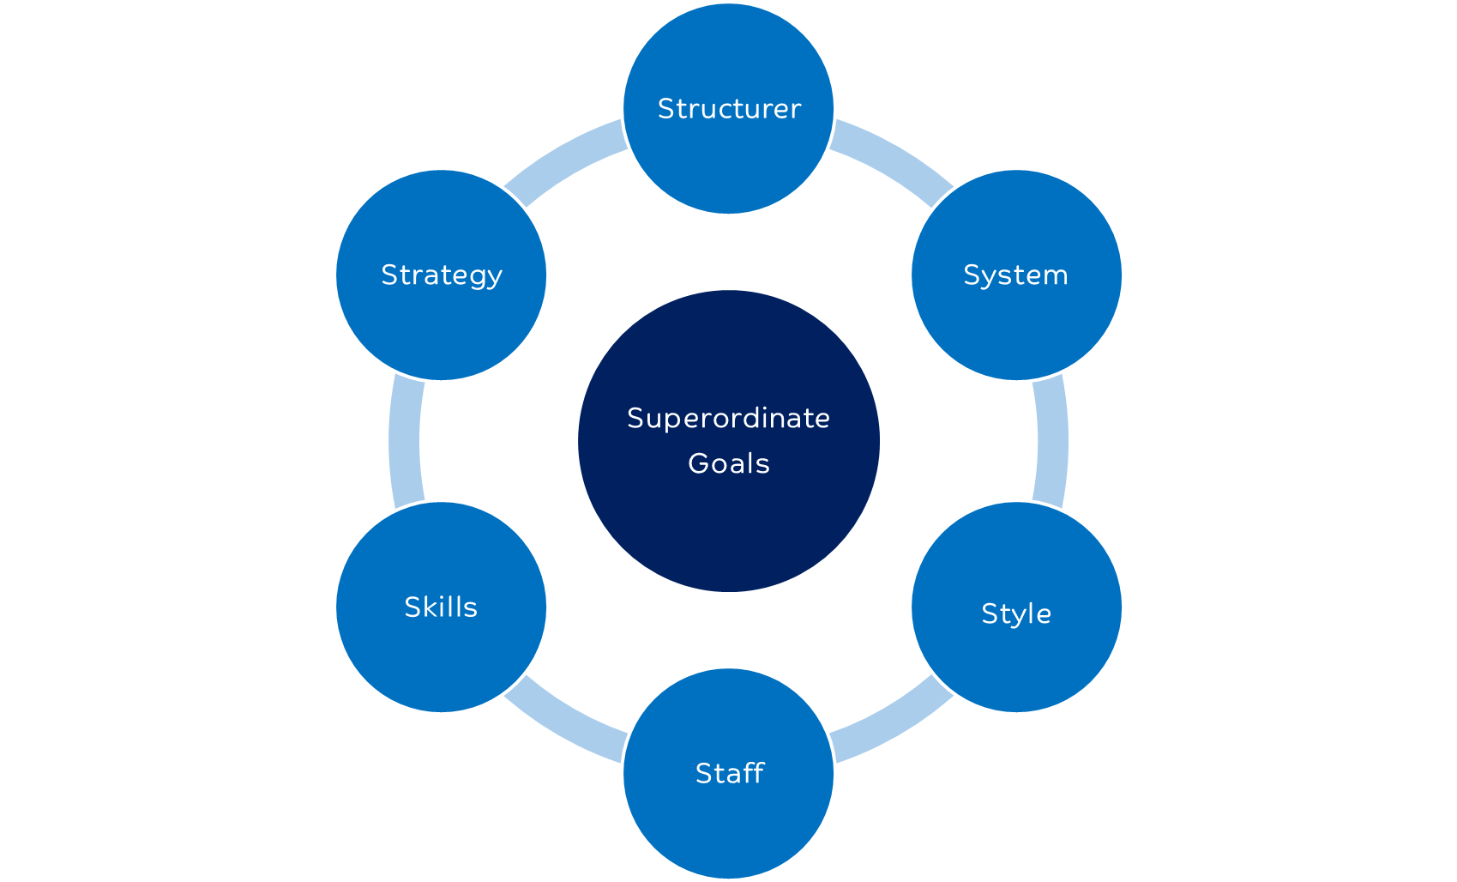
The McKinsey framework is a model to examine organization effectiveness, and improve performance by managing changes within an organization based on seven elements: goals, structure, strategy, system, style, staff, and skills. The model argue that organization restructure, strategy improvement, systems enhancement, staff and skills development are changes could lead to better outcomes. (Peters & Waterman, 1980)
Buyers of direct materials deal with a variety of category planning and operation roles. Managing purchases within a category requires high engagement with stakeholders. Category planning involves sourcing new products from suppliers and monitoring them through quality approval, which includes lab testing approval for Manufacturing, end-user commercial trial runs, and volume forecasting with the production team, in addition there are operational roles such as RFQ publishing, spot buying, contracting, expediting shipments with Logistics, and maintaining good relations with suppliers.
With the current procurement cycle, buyers of direct materials are often multitasking, which leads to less efficiency on deliverables. A study found that the amount of time spent on multitasking, and switching between tasks caused workers to lose more time overall, as their duties became increasingly complex﻿﻿. (Rubinstein and Meyer, 2001)
With these inefficiencies, obstacles begin to accrue, such as open PRs for technical evaluations from the laboratory, late international shipments, lost or misplaced materials, high detention costs, and high yard costs.
Model 2.2 Direct Material Organization Restructure
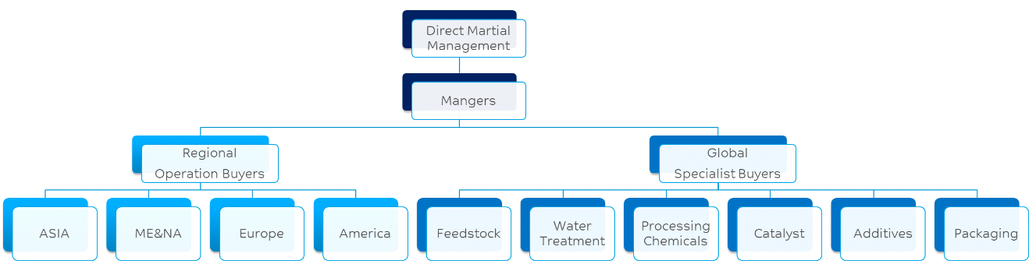2.2 Model explains how restructuring direct material organization will allow stakeholders, to coordinate closely and effectively on the strategic sourcing plan. Segregating the role of buyers in the procurement cycle shown in Model 2.1 into two types of buyers, global specialist buyers and regional operational buyers, will in turn segregate the procurement cycle of direct material management.
Buyers with technical backgrounds in the various categories can manage closely with Manufacturing, the end-user and the production team within their region. With this practice, global specialist buyers can forecast the demand for categories effectively, save the effort of duplicating quality approval tasks and apply it to scouring alternatives, specify end-user requirements accurately, and pass the relevant information along to regional operational buyers. With strong analytical skills and effective communication, regional operational buyers will carry out operation tasks and focus on delivery.
Restructuring the organization of direct materials requires classifying direct material categories in a new way in order to manage category expenditures effectively through a strategic sourcing plan.
Model 2.3 Kraljic Matrix: Portfolio Purchasing Model.
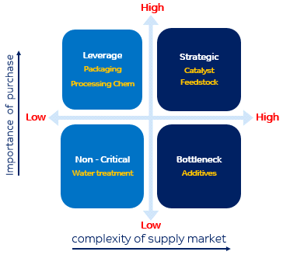
The Kraljic Matrix is a method of classifying purchasing categories based on two main factors: the importance of the purchase, and the complexity of the supply market. In this case, different categories of direct materials are measured in terms of their attributes, applications, usage, availability and price. These define each category’s production impact and supply risk, which in turn classify them into four purchasing positions: Non-Critical, Leverage, Bottleneck and Strategic. (Kraljic, 1983)
As shown in Model 2.3, with Government support on water desalination plants and the production of oil and gas downstream products, along with support from NRPCO on common packaging production, the categories of water treatment, processing chemicals and packaging rank at a relatively low level of complexity of their respective supply markets, due to low supply risk from the variety of local suppliers with multiple sources and low prices. However, processing chemicals and packaging are highly important to purchase, due to their high impact on production. Processing chemicals such as oil and gas downstream products like fuel and lubricants can be a source of energy or a tool for processing feedstock in the production line, and packaging protects the final product’s condition, quality, and ensure that NRPCO’s logo stands out on competition. As such, both of these direct materials are classified in the ‘Leverage’ purchasing position. On the other hand, water treatment is an important resource for general plant use, but with common standards and procedures for building utilities in all-NRPCO manufacture affiliates, recycling rain and wastewater is an effective alternative method, lowering the importance of purchase this direct material. Because water treatment has a relatively low impact on production, it is classified as ‘Non-Critical’.
For the categories of feedstock, catalysts and additives, the complexity of the supply market is high, due to few sources caused by oligopoly of local or global market of feedstock and additives, or single or sole sources caused by monopoly of catalysts market. As such, these direct materials carry a high supply risk. Additionally, as feedstock is a main direct material for producing final products like chemicals, fertilizers, plastics, and metals. It is highly influential in determining the price of final products, and catalysts are a crucial substance for optimizing the production process with less errors, shorter completion times, and lower costs. Both direct materials are given a classification of ‘Strategic.’ On the other hand, because additives merely add a function or features such as color, purity, or solidity of plastic, with alternatives that can be substituted upon customer approval, they are considered of low impact to production and classified in the ‘Bottleneck’ purchasing position.
As the materials in the Leverage purchasing position, such as plastic packaging are built to universal standards across all NRPCO manufacturing affiliates, and consumed in huge volumes. Capitalizing on opportunities within this growth area to gain new techniques for efficient expenditure management will lead to savings and add value to NRPCO’s business.
Model 2.4 Make Or Buy Decision.
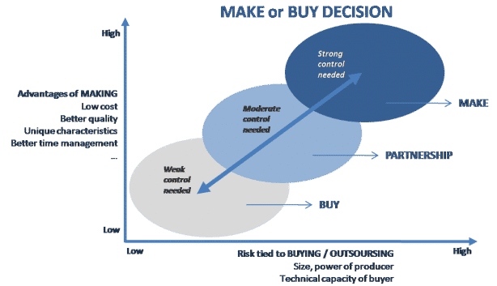
The make-or-buy decision model is used to decide between manufacturing an item internally, or buying it from an external supplier based on two main factors, the advantage of making presumed by qualitative method, and risk to buy presumed by quantitative method. The qualitative method, analysis making through value chain of manufacturing, and outline the advantage of being made in-house. On the other hand, quantitative method presumes the cost to make and compares it with the cost to buy (Luenendonk, 2015).
Currently, NRPCO procurement purchase plastic packaging from suppliers through short-term agreements, and assures cost saving and discounted price through leveraging and economy of scale. However, while the price for this category is fluctuating globally, purchasing agreements do not guarantee a fixed price for the plastic packaging category in the upcoming years, which puts cost slightly at higher levels.
Plastic packaging cost influenced by oil pricing, due to the petroleum component on making this product. Additionally, the variation in additives used in manufacturing is reflected in the pricing mechanisms of the final product. Other factors, which influence the final cost of plastic packaging, are the costs in terms of water, fuel and energy. Study has shown that combined costs of vehicle fuel, energy, and water increased from $86.9 million to $93.8 million in 2012, an average price increase at a rate of 1.0% per year. Subsequently, the general price has risen by 2.0% in the recent years. The most sensitive factors that mainly affect the pricing in this category are the individual costs of water, fuel, and energy. The pricing mechanism considers these factors, since the overall costs gradually increase with time, considering buy or make decision will add value on cost saving for this category (Selke, Susan, & John 2015, 40, 70, 134).
NRPCO procurement decision is to buy at low risk when it comes to purchasing the best quality materials from suppliers who are specialized in the manufacturing plastic packaging category. Since NRPCO is supplied with low cost oil and gas supported by the Government, and specialized to produce plastic raw materials, considering the decision to make plastic packaging in- house is at low cost. On the other hand, NRPCO’s decision to make at high risk when it comes to produce the best quality plastic packaging, the decision requires procuring machinery, technology and production line, and hiring experts to produce plastic packaging materials, which requires time and effort out of NRPCO’s scope of business. However, considering the decision to outsource for this particular category, keeps cost and risk at moderate level. Therefore, the decision to outsource plastic packaging within the region is the right choice for NRPCO.
With low-priced plastic raw materials supplied to outsourced supplier, who in turn, produce the best quality plastic packaging materials and supply it back to NRPCO, procurement can achieve cost saving and control quality.

Model 3. Inclusions That Should Be Made In Contracts Formed In The Future.
A procurement contract is where a buyer agrees to purchase goods and services in exchange of a consideration. The main types of procurement contract are fixed price contract, cost reimbursement contract, time and materials contract and the requirement-type procurement contract.
Procurement contracts and commercial agreements have provisions that protect the interests of buyers and suppliers. In commercial agreements, developing specification is an essential inclusion that should be made in forming contracts. Proprietary, generic, brand specifications, and vendor assistance in specification preparation, are important in giving a sufficient description to the product. These specifications empower material standardization (MS) to update material attributes in the procurement system, and support buyers on sourcing plans. Additionally, theory application and outcomes, contract proposals and change, and factors affecting implementation are important inclusions to document corrective and preventive actions.
Model 3.1 Developing Specifications
The risk related to the development of specifications spins around a prospective narrow definition of commercial specifications. This can be attributed to limited alternatives and increased costs that were not initially indicated in the contract.
Performance Management For Compliance To Agreed Standards
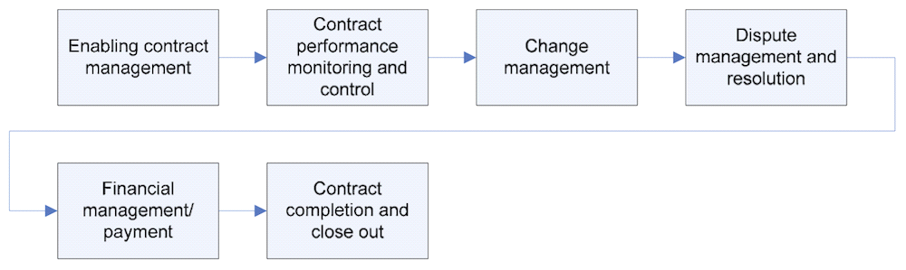
The flowchart of Model 3.2 specifies the effective management and compliance to agreed standards in the management and performance of a contract. It involves sharing different perceptions on contract management processes and delegating tasks to enhance efficiency. The performance and nursing of the agreement should be precise to avoid a possible violation of the provisions. In addition, the management of possible disputes should be focused on strong management principles to ensure ultimate completion and implementation of the contract (Bajari, and Steven 2001).
Payment responsibilities in contract management
The payment of commodities in contract management is done independently from the procurement processes under the sole care of the buyer. The buyer will independently follow up and ensure that all contractual payments are promptly made to the various parties in the contract.
Targets for assessment of performance of suppliers based on the SMART target for performance.
The set criteria should be specific on the relevant actions that are easy to comprehend, and which can be measured for verification. The targets set should also be attainable in the sense that they should be realistic based on the inherent capability of the contracting parties. The contract should also be based on achieving the set outcomes within a set period, which should also be reasonable enough.
Model 3.2 Different Types Of Specification Typically Used In The Procurement Of Goods And Services
Specifications are very precise and can be used in enhancing or inhibiting various forms of competition in contractual agreements. This can be ascertained by giving descriptions of various commodities in way that the inherent needs are met and competition encouraged. Unless otherwise deliberately stated, all the accompanying commodities must be in good condition, and if possible new. Some of types of specification typically used in the procurement of goods and services are stipulated in the subsequent discussions (Mattoo 1996, 670).
Generic
Under this form of specification, the buyer is required to carry out an analysis of the various requirements with an inherent view of lobbying the obligations based on generic specifications. Depending on the appropriateness of the situation, specifications related to various performances under this type of specification are permitted.
Brand Name or Equivalent
When it can be established that the development of generic specifications is actually impractical, the designation of the brand may be used in conveying the general style, features and quality of the anticipated articles. Unless otherwise stipulated, brand name should, however, not put any restriction on a particular brand of category (Mattoo 1996, 672).
Proprietary
This type of specification puts more restrictions on the ‘acceptable products’ as those specified or associated with a manufacturer(s). Proprietary specifications are mostly used in cases whereby the anticipated category is compatible with the intrinsic components of the existing category.
Vendor Assistance In Specification Preparation
Under this type of specification, the supplier is allowed to give advice on certain preferred characteristics that a manufacturer should execute. However, no individual, for recompense, shall prepare an ‘invitation to bid’ on behalf of the populace.
Information that can be used in creating specifications such as standards, internet, suppliers and directories
Gathering adequate information from various parties on the functionality and performance of the desired good or service is a crucial source of information in the creation of a specification (Mattoo 1996, 679).
Segments of a specification: Scope, definitions, descriptions of requirements
The initial wordings of a specification should be based on general description, ordering, and scope of the anticipated category.
List of requirements
This entails recognizing only such measurements that are specific to the functionality and quality of the desired product.

Theory Application And Outcomes
Associated theories and models are a key component in procurement processes especially in purchase decision-making. Resource dependency theory, and organizational decision-making theory, transaction cost analysis theory, and game theory are key among the theories that dominate purchase decision-making. The practice and outcomes of the application of these theoretical aspects provide a guideline in the supply chain process, especially in the performance of a contract and vendor management (Burgess et al., 2006).
Procurement Proposals And Change
The procurement proposals are adapted automatically by the system during a run, but can be altered to meet the desired requirements of the time. This can be achieved through firming the proposals. Such proposals include, purchase requisitions, planned orders, and delivery schedules. Through firming of the proposals, certain business improvements are achieved, as the changes are effected to achieve certain business objectives.
Factors affecting implementation of procurement proposals
Adoption of ICT
Effective procurement processes involve the application and exploitation of information technology. For effectiveness and transparency, the budget proposals are implemented in a manner that avoids aspects such as fraud. Without ICT, these proposals become difficult to implement and also prone to alterations.
Ethics
Moral values and principles are an important aspect in creation and implementation of proposals. They guide the expenditure and the ethical behavior of the implementers, and hence, reduce budgetary expenditure that is at times escalates due to fraud and other unethical behavior. It is therefore prudent to observe such aspects in the implementation plan of the proposals made to ensure that the changes are realized. (Wee 2002)
Model 4. Measures That Can Be Taken To Select Effective Suppliers
There are a variety of methods to select effective suppliers and this section covers the most important steps, which includes identifying supplier, determining supply performance, analysis of financial factors, and creating a contract. (Spend Edge)
Step 1. Identify suppliers Identifying supplier starts with identifying the scope of work and expectations from prospective suppliers, buyers should take in consideration the five right business priorities model when comes to supplier selection: right time, right price, right quality, and right quantity (Oxford College, 2019).
Each priority differs on ranking based on direct material categories level of importance to business and level risk of supply, buyers may spend more time on analyzing supplier profile to prioritize right quality and time for strategic material, and prioritize right price, quantity, and place to select a local supplier for leverage materials.
Step 2. Determine supply performance
Suppliers selection should conduct audit and quality approval processes through multiple stages, to examine strengths and weaknesses and assure supplier capability to meet business expectations. Forms of audit and quality approval process include site visits, and obligating prospective suppliers to obtain industrial and a commercial standards certificate from the International Organization for Standardization (ISO), to assure that prospective suppliers meet minimum requirements in terms of quality, reliability and safety standards. In addition, to products quality approval, prospective suppliers’ products samples should be obtained along with Safety Data Sheets (SDS) and Technical Data Sheets (TDS), and certificate of analysis (COA) for quality testing at laboratory. (ISO)
Step 3. Analyze financial factors Assessing the financial viability of a prospective supplier helps to analyze overall supply risk, financial strength and competitive advantage factors. Financial performance and position, as reflected in the income statement and balance sheet, can help a buyer to develop a SWOT analysis for prospective partner or strategic supplier, based on analysis of ratios in respect of liquidity, solvency, profitability, asset use efficiency, and investment return (Carlson, 2014).
Liquidity analysis shows a prospective supplier has the funds to meet demands for payment from short-term liabilities, while solvency ratios show the threat of bankruptcy due to the levels of debt.
Profitability helps to assess whether a prospective supplier will be able to continue in the near future, while asset efficiency ratios show efficiency of using assets. Additionally, investment return ratios show the return that an entity offers to its shareholders.
With the above ratios analysis, the buyer can develop SWOT analysis mapping the strengths, weaknesses, opportunities, and threats to determine a prospective partner or strategic supplier’s eligibilities and capabilities to business.
Step 4. Create a contract
Creating a contract is perhaps one of the most crucial steps in any supplier selection process. Companies should use this as an opportunity to negotiate with top suppliers while keeping other suppliers on the list of potentials. After the agreement is reached, a contract can be created and signed. In many cases, the purchase order is considered a contract, but companies can even have a contract and then create a purchase order, depending upon the complexity of the situation.

Model 5. Any Aspects Of The Purchase/Supply That May Require Negotiation.
Referring to Model 2.1, the McKinney 7S Framework, creating a new style leads to add a new value to an organization, and one of the most important styles in procurement process is negotiation with suppliers. Negotiation to purchase non-critical or leverage materials seems a normal process with suppliers. However, it is a complex process to purchase bottleneck or strategic materials with powerful suppliers. A developed style of four strategies on ‘how to negotiate with powerful suppliers’ can balance the power between buyers and suppliers (Paranikas, Whiteford , Tevelson, & Belz, 2015).
Four Strategies On How To Negotiate With Powerful Suppliers.
Strategy 1. Bring new value to the supplier.
Rebalance the power equation and turn a commercial transaction into a strategic partnership in two ways: Be a gateway to new markets, and reduce the supplier’s risks.
Be a gateway to new markets.
Bottleneck or strategic materials suppliers are most likely have scope of business close to NRPCO’s business, searching for products within NRPCO marketing team to support suppliers on their business creates mutual interests that balance power between buyers and suppliers.
Reduce the supplier’s risks.
Requesting to produce special type of additive with tight specifications can be a loud of processes to supplier, which reflects on price and risk to supply. Negotiating a tolling agreement to supply additive raw materials to additive manufacture will secure price, quality, and surety of supply (Vinter & Price, 2006, 130).
Strategy 2. Change how they buy.
In this case, creating opportunities for new value is not possible with the supplier. Therefore, changing demands is an alternative and can be done in three ways: consolidate purchase orders, rethink purchasing bundles, and decrease purchase volume.
Consolidate purchase orders. Purchasing a high volume from one supplier has an advantage of controlling price, consolidating demand of several materials to purchase from one supplier, empowering a buyer to negotiate a discounted price. However, relying on one supplier may affect surety of supply, while dividing demand between two or three suppliers can achieve acceptable weight average price for all suppliers, and lower dependency to supply from one source.
Rethink purchasing bundles.
In this strategy, a buyer will negotiate with one or two suppliers in a monopoly market, the buyer will start on a qualifying process with two suppliers and chose one to award a single contract, through this strategy the buyer can pick apart existing bundles, create competition among the two suppliers and renegotiate new agreements in the future requesting a better deal.
Decrease purchase volume.
Decreasing volume to purchase from a certain supplier increases the supplier's openness to negotiate with the buyer for a better deal, due to the threat of losing the whole deal.
Strategy 3. Create a new supplier.
Qualifying a new supplier is an option to change procurement style, it might be risky to business. However, by evaluating a supplier’s profile, capability, commitment, and financial viability, can build a partnership to enter a different market or invest in a new category.
Strategy 4. Play hardball
This is a style used by buyers to cut off all ties, by canceling all orders, excluding the supplier from future business, or threatening litigation. By using these actions, the buyer send a clear message to the supplier that, if mutual benefits cannot be achieved, then business cannot be continued, and with the threat to lose business, the supplier will come back to negotiation of mutual benefits.

Conclusion and Recommendation
There are three commodities of expenditure at NRPCO, of which direct material is one of the most important due to the importance of application and usage of these materials on the production line. The production forecast and the consumption plan of direct materials are correlated, the consumption plan specifies end-user requirements based on the production forecast, the higher the volume to be produced, the higher the volume of direct materials to be consumed. Managing expenditure to develop a source plan of direct materials requires outlining stockholder input into the process of procurement and supply. Through the stakeholder analysis model, stakeholders are positioned to four classifications, based on their involvement in the procurement process and interests in the sourcing plan. Buyer, end-user, manufacturing and production team are classified as ‘manage closely’ stakeholders and high engagement between those stakeholders leads to effective expenditure management and sourcing plan.
The report outlines techniques for adding value to this type of expenditure, through the McKinsey 7S Framework model, which argues on change in organization structure leads to effective utilization of the staff, their skills, and procurement process. The report recommends restructuring the organization by segregating the role of buyers in the procurement cycle into two types, specifying end-user requirements accurately, saving the effort of duplicated work, and gaining more focus on delivery. Additionally, the report outlines another technique to add value through the strategic sourcing plan of the Kraljic Matrix model. In this model, direct material is positioned in four classifications, non-critical, leverage, bottleneck and strategic, to support the decision of make, buy or outsource. The report recommends outsourcing decision for leverage material, such as plastic packaging, which leads to added value on cost-saving and close control on plastic packaging quality. The report also recommends that development of accurate specifications is important, and inclusions should be made in the contract. This empowers material standardization (MS) to update material attributes in the procurement system, and supports the buyer in sourcing plans, while theory application and outcomes, and contract proposals and change, are important inclusions to document corrective and preventive actions. The report recommends selecting effective suppliers in four steps, a buyer can develop a SWOT profile for a prospective strategic supplier or partner by assessing the financial viability, which helps to analyze overall supply risk, financial strength and competitive advantage factors. Further, the report covers important aspects in purchasing strategic materials with powerful suppliers, and recommends a negotiation style of four strategies to balance the power between a buyer and supplier.
Work Cited
NRPCO Annual report (2019), https://www.NRPCO.com/en/investors/performance-financial-highlights/annual-report
De Mascia, S. (2016). ‘Engaging stakeholders, steakehoder analysis’ Techniques to Create a Successful Project. Project Psychology, CRC Press. pp. 73–74. https://books.google.com.sa/books?id=G5XsCwAAQBAJ&pg=PA73&redir_esc=y#v=onepage&q&f=false
Waterman, R. H., Peters, T. J., & Phillips, J. R. (1980). ‘McKinsey 7S Framework’ Structure is not organization. Business Horizons, 23(3), 14-26. https://www.mckinsey.com/business-functions/strategy-and-corporate-finance/our-insights/enduring-ideas-the-7-s-framework
Peter Kraljic, (1983). ‘Purchasing Must Become Supply Management.’ Harvard Business Review https://hbr.org/1983/09/purchasing-must-become-supply-management.
Joshua Rubinstein and David Meyer, (2001). ‘Executive Control of Cognitive Processes in Task switching’. Journal of Experimental Psychology, Human Perception and Performance https://www.apa.org/pubs/journals/releases/xhp274763.pdf
Bajari, Patrick, and Steven Tadelis. (2001). ‘Incentives and transaction costs’ RAND Journal of Economics. 387-407.
Martin Luenendonk (2015).’ make-or-buy-decision-step-by-step’ Cleverism
https://www.cleverism.com/make-or-buy-decision-step-by-step-guide/Bajari,

John, Joel. (2016) ‘Global Plastic Packaging Market Poised to Surge from USD 270.0 Billion in 2014 to USD 375.0 Billion by 2020.’Market Research Store, 2016 https://globenewswire.com/news-release/2016/03/01/815660/0/en/Global-Plastic-Packaging-Market-Poised-to-Surge
Selke, Susan E. M, and John D. Culter. (2015) Plastics Packaging: Properties, Processing, Applications, and Regulations. Hanser
Patrick, and Steven Tadelis. (2001) ‘Incentives and transaction costs’ RAND Journal of Economics 387-407.https://www.jstor.org/stable/2696361?seq=1
Mattoo, Aaditya. (1996) ‘Government procurement agreement’ The world economy 19.6: 695 -720.
Wee, H.(2002) ‘Corporate ethics’’ Business Week 11,12,17
https://www.bloomberg.com/news/articles/2002-04-10/corporate-ethics-right-makes-might
Spend Edge, ‘4 Effective Steps to Successful Supplier Selection’ https://www.spendedge.com/blogs/4-effective-steps-successful-supplier-selection
Oxford College, (2019). ‘A Broader Look At The Five Rights of Procurement’. https://www.oxfordcollegeofprocurementandsupply.com/the-five-rights-of procurement ISO - International Organization for Standardization https://www.iso.org
Rosemary Carlson. (2014) ‘Categories of Financial Ratios’ Financial ratios provide an economic portrait of a business. https://www.thebalancesmb.com/categories-of-financial-ratios-393217
Paranikas, Whiteford , Tevelson, Belz. (2015) ‘How To Negotiate with Powerful Suppliers’. Harvard business review. https://hbr.org/2015/07/how-to-negotiate-with-powerful-suppliers
Graham D. Vinter, Gareth Price.(2006) ‘Tolling agreement’ Project Finance: A Legal Guide, page 130. https://books.google.com.sa/books?id=8wz4MpHS4FsC&pg=PA130&lpg=PA130&dq=semi+tolling+agreement&source=bl&ots=h7- e

