Innovation case studies assignment outline
Assignment information:

Innovation Case Study Journal
Submit no more than 1,500 words (or 300 words per case study weeks 1-5) of journal responses. Students will be expected to demonstrate a critical awareness of the wider practical and theoretical contexts of the innovation themes introduced in the first five weeks of the course in their journal responses.
Each week you will address the following questions in your journal response;
- What main learning points did you acquire from this week’s lecture series?
- How has this week’s lecture series progressed your understanding of innovation theory and concepts?
- What key insights into the opportunities and challenges facing the management of innovation did you acquire from this week’s lecture series?
Advice:
For each week it is essential that you view the recording to critically answer the 3 questions and use guest speakers to support and key readings to support.
How to answer the questions
What main learning points did you acquire from this week’s lecture series?
•for this question address the “what”- summarise what core concepts were addressed this week in your lecture.

How has this week’s lecture series progressed your understanding of innovation theory and concepts?
•for this you must address “how” the case study examples either presented by Chris or the guest link back to your reading material.

What key insights into the opportunities and challenges facing the management of innovation did you acquire from this week’s lecture series?
•In this section we would expect you to critically review the opportunities and or challenges facing the core theme or case studies presented that week.

The focus of each week:
Week 1: Creative destruction and Covid-19
Week 2: Aggregation of marginal gains.
Week 3: Frameworks and blueprints in business competition
Week 4: Innovation across industries and markets
Week 5: Ecosystem - Sustainable and predatory growth

Guest speakers by week:
- Week 1 Guest Speaker:
Fiona Camenzuli People & Organisation Network Leader, PwC United Kingdom
- Week 2 Guest Speaker:
Matteo Berlucchi, CEO and Co-Founder, Your.MD
- Week 4 Guest Speaker 1: Industry deep-dive, financial services
Nicola Horlick, CEO Money&Co
Week 4 Guest Speaker 2: Industry deep-dive, Healthcare Bill Hammond, Pediatric Surgery Fellow, Calgary, Alberta, Canada
- Week 5 Guest Speaker: Ed Williams, Edelman, UK and Ireland CEO

The guest speaker for week 3 is Chris the lecture

resources to use
week 1: refer to lecture 1 slides, recording(ICS week 1) as well as examples
week2: refer to lecture 2 slides, recording (ICS Week 2) and metteo’s slidedeck Healthily_for_Goldsmith_-_MSc_Presentation.pdf
week3: refer to recording and creating a blueprint for UK competitiveness report
weeK4: refer to Lecture recording and Bill Hammond’s Slides Univ of London 10-27-2020.pdf

week 5: refer to recordings(ICS week5) and innovation week5 audio for guest speaker

Key References you must include:
Albu, A. (2017) ‘Fundamentals of Innovation’, in Moya, B. L., Gracia, M. D. S. de, and Mazadiego, L. F. (eds) Key Issues for Management of Innovative Projects. InTech, pp. 3–24. doi: 10.5772/intechopen.69005.
Bejan, A. and Lorente, S. (2012) ‘The S-Curves are Everywhere’, Mechanical Engineering, 134(05), pp. 44–47. doi: 10.1115/1.2012-MAY-5.

The Singularity: A Philosophical Analysis in Journal of Consciousness Studies
ISSN
1355-8250 vol 17 issue9 pp7-65
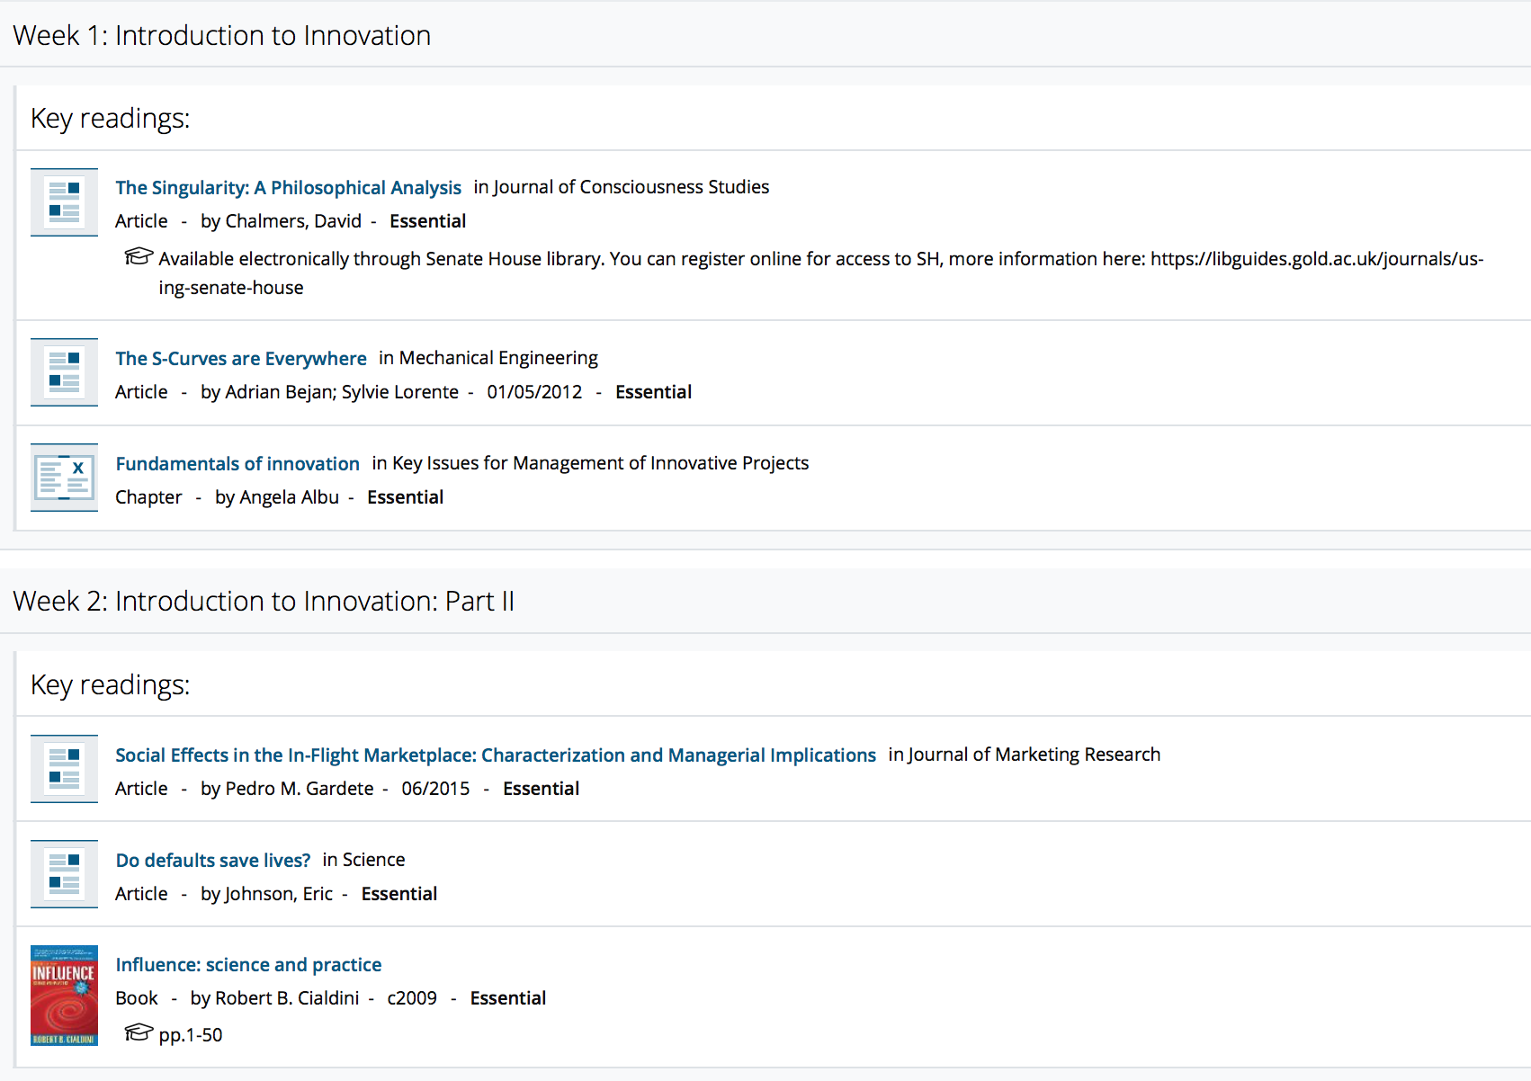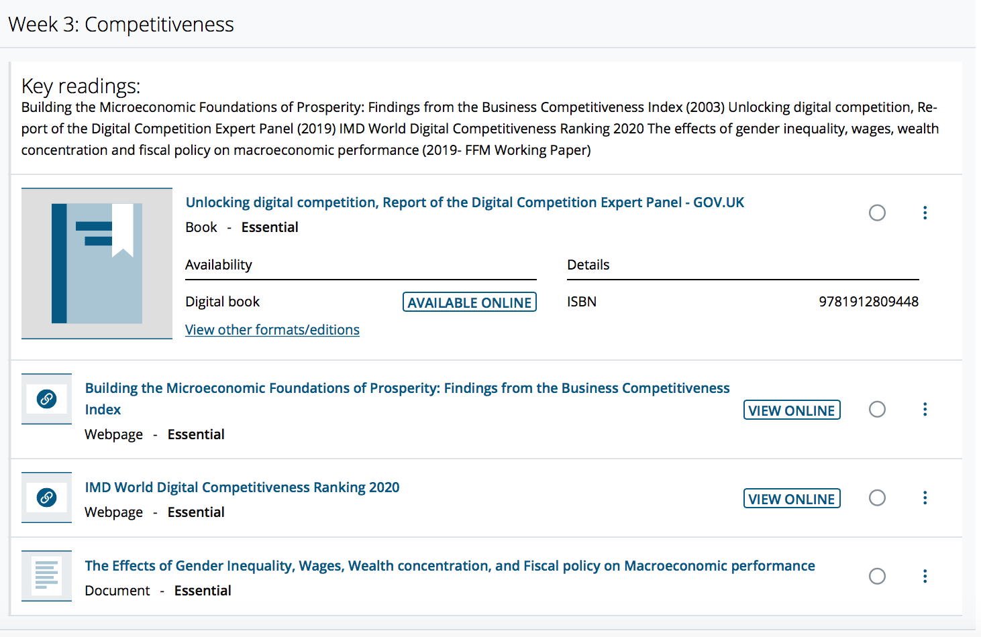 http://citeseerx.ist.psu.edu/viewdoc/download?doi=10.1.1.372.2547&rep=rep1&type=pdf
https://www.imd.org/wcc/world-competitiveness-center-rankings/world-digital-competitiveness-rankings-2020/
https://www.boeckler.de/pdf/v_2019_10_26_onaran.pdf 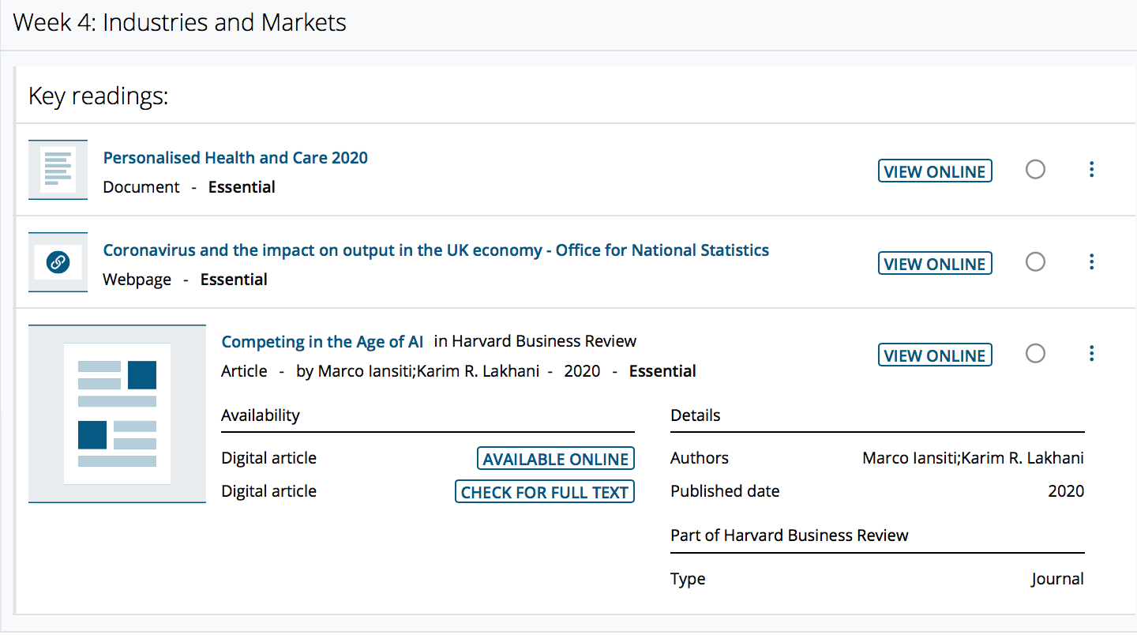
https://assets.publishing.service.gov.uk/government/uploads/system/uploads/attachment_data/file/384650/NIB_Report.pdf
https://www.ons.gov.uk/economy/grossdomesticproductgdp/articles/coronavirusandtheimpactonoutputintheukeconomy/august2020
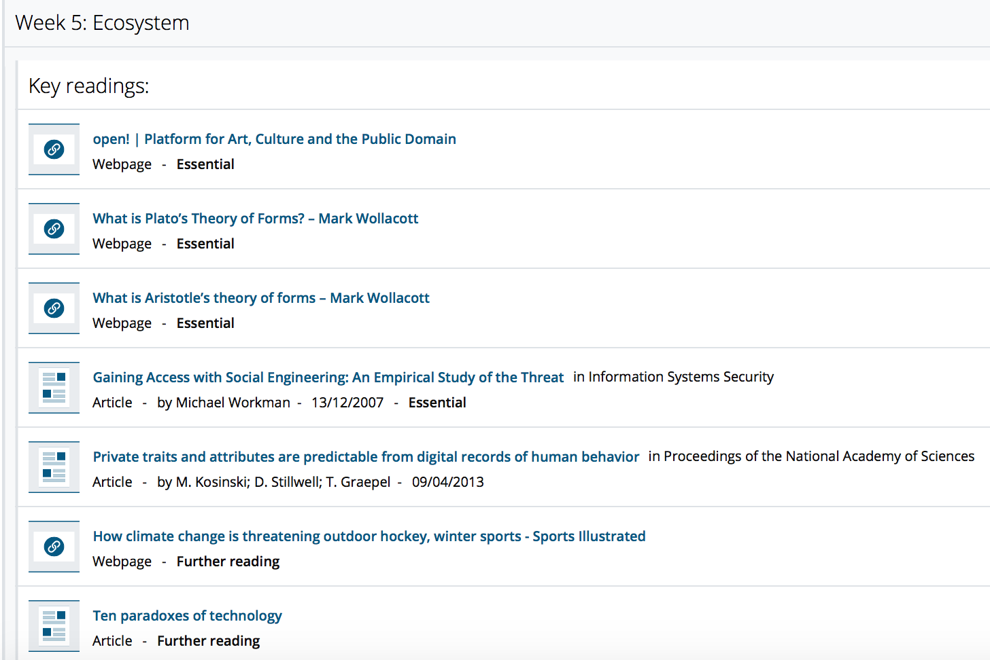 https://onlineopen.org/cold-storage
https://mwwollacott.com/what-is-platos-theory-of-forms/
https://mwwollacott.com/what-is-aristotles-theory-of-forms/
Gaining Access with Social Engineering: An Empirical Study of the Threat
DOI 10.1080/10658980701788165
private traits and attributes are predictable from digital records of human behavior
Pages 5802-5805 ,DOI10.1073/pnas.1218772110
https://www.si.com/nhl/2019/04/22/climate-change-canada-winter-sports-hockey-backyard-rinks

