Renewable Energy

Tutor-marked assignment (TMA 01)

TMA 01

Question 1
Study Guide 2 explored U-values and how heat energy is transferred through windows. After your study of Chapter 2 of Renewable Energy, guided by Study Guide 2, you should be able to explain heat energy flow through the materials in buildings, especially windows.
- a. State the three main mechanisms for heat transfer through a window, and briefly indicate how the heat energy is transferred through a window in each case.
3 marks
- b.Original double-glazing designs simply featured an air gap between the two panes of glass. Since 2013 the minimum acceptable UK Windows Energy Rating for new and replacement windows (on a scale of A to G, with A being the best) is C. Argon filled units with a gap between 12 and 16 mm are able to achieve this. However, this is a potential problem for historic buildings.
Explain, with reference to the gap dimension and the properties of the contents of the gap, how glazing units with acceptable UK window regulation U-values may be achieved.
2 marks
- c.

Table 1: Building Research Establishment, 2014
Glazing type | U-value  (W m⁻² K⁻¹)
Single glazing | 4.8
Double glazing (normal glass, air filled) | 2.7
Double glazing (hard coat low-e, emissivity = 0.15, air filled) | 2.0
Double glazing (hard coat low-e, emissivity = 0.2, argon filled) | 2.0
Double glazing (soft coat low-e, emissivity = 0.05, argon filled) | 1.7
Triple glazing (soft coat low-e, emissivity = 0.05, argon filled) | 1.3

  - i.In a house with a 3.0 m² single glazed window, what is the total rate of heat loss on a day where the outdoor and indoor temperatures are 3°C and 18°C respectively? (Data may be assumed to have been supplied to 2 significant figures (SFs)).
1 mark
  - ii.Assuming the temperature difference remained the same throughout a 24-hour period, what would be the total heat loss in kWh over the day?
1 mark
  - iii.What would the heat loss be over a 24-hour period if the single glazed window were replaced with a triple glazed window?
1 mark
(Total for Question 1 is 8 marks)

Question 2
- a.Briefly define, in your own words, the meaning of the phrases “winter design temperature” and “heat loss coefficient (HLC)”.
2 marks
- b.Briefly explain, in your own words, how degree-days and the heat loss coefficient (HLC) of a house can be used to estimate heating fuel bills.
2 marks
- c.A couple are renovating a house with no functioning heating system. Fortunately, one of them has studied T313 and Study Guide 2 helped them work out the whole house heat loss coefficient (HLC) as 160 W K⁻¹.
  - i.Estimate a suitable power output for the heating system, Q_{h}. Assume an internal temperature of 20°C and a winter design external temperature of -5°C. Express your answer in kW to 2 significant figures.
2 marks
  - ii.Using the HLC value how many kWh per year of heat energy would be required if the annual total degree-days for the area in which the house is located is 3126? Assume data is supplied to 2 significant figures.
2 marks
(Total for Question 2 is 8 marks)

Question 3
Sunpath diagrams are useful tools when assessing a site in terms of its “solar potential”. Figure 1 shows the apparent daily path of the sun across the sky at the equinoxes for a certain location in the northern hemisphere. Data points are marked at hourly intervals along the sun path

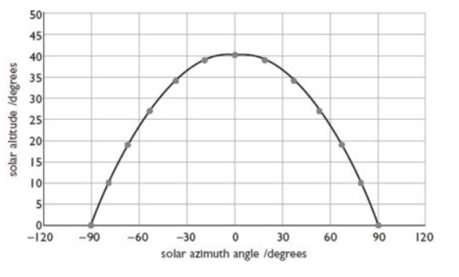
Figure 1 Sunpath at the equinoxes
- a.Using Figure 1 as a basis sketch the sunpath at (i) midsummer and (ii) midwinter. Mark clearly, and identify quantitatively, the altitude of the noon (GMT) sun at this location in each case.
2 marks
- b.A potential site for roof-mounted solar panels at this location has the following two disadvantages:
  - A nearby low rise building blocks out any morning sun between east and south-east until it reaches 12 degrees above the horizon.
  - A distant tall narrow building hides the afternoon sun below a solar altitude of 32 degrees when it reaches an azimuth angle of 60 degrees. It reappears one hour later.
  - i.Annotate the sketch produced for your answer to Q3(a) with shapes which represent the effects of the two buildings in blocking out the sun.
2 marks
  - ii.Estimate the number of hours during the day when the sun will reach the site at the equinoxes. (An answer to the nearest half hour is acceptable.)
2 marks
  - iii.Comment briefly on the likely effect of the two buildings described above at midsummer and at midwinter.
2 marks
(Total for Question 3 is 8 marks)
Your answer to this question should be in the form of a single diagram for Q2(a) and Q2(b)(i), an estimate / calculation for Q2(b)(ii) and brief comments for Q2(b)(iii).

Question 4
- a.Explain briefly, in your own words, the difference between active and passive solar heating in buildings. Explain further why it may be considered that there is no clear boundary between the two.
4 marks
- b.Briefly describe, in your own words, ONE example of the use of each of the above types of solar heating in domestic dwellings.
4 marks
Your answer for Q4 should consist of fewer than 250 words in total. Answers consisting of more than 250 words will have 2 marks deducted.
(Total for Question 4 is 8 marks)

Question 5
- a.A communications link, serving a scientific outpost on the Amazon, obtains its power from a photovoltaic (PV) panel. The system needs to run continuously, so it includes a rechargeable battery as backup. The continuous power consumption of the system is 2000 mW.
There are 30 PV cells in the panel and under daylight conditions each cell produces a current of 1.80 A at a voltage of 0.50 V. Show that in these circumstances the panel is producing more than 13 times the power needed to run the link.
4 marks
- b.During a worst-case scenario there could be effectively no solar input for as long as 72 hours. How many Wh of energy will the battery need to supply to run the link for this period?
1 mark
- c.If this “zero input” period is followed by a return to the conditions in part (a), how many hours will it take for the panel to recharge the battery?
(You may ignore any energy losses in the battery discharging/recharging process)
3 marks
(Total for Question 5 is 8 marks)
Assume that all data in this question is given to 2 significant figures.

Question 6
Use the PV SAP spreadsheet to compare the output of a 2 kWp domestic PV system in two different UK locations:
- Orkney (NHER DD region 20) for solar correction factor
- Bristol (NHER region Severn, DD region 5) for solar correction factor.
Assume for each case:
- a south facing roof
- a pitch of 45°
- little or no overshading.
- a.What is the annual (NHER) output for the scheme in Orkney in kWh y⁻¹? State your answer in kWh per year and also copy and paste an image of the PV model as shown (once you have adjusted it with the required values):
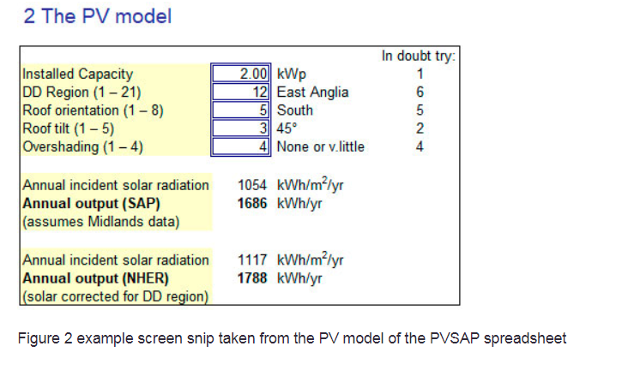
Figure 2 example screen snip taken from the PV model of the PVSAP spreadsheet
2 marks
- b.What is the annual (NHER) output for the scheme in Bristol? Again state your answer and also copy and paste an image of the PV model.
2 marks
- c.Describe four factors that determine the electrical output of a solar PV system. Answers can be achieved in no more than 175 words. Any answers longer than 200 words will be penalised by deducting 1 mark.
4 marks
(Total for Question 6 is 8 marks)

Question 7
Battery storage is explored in Study Guide 4, Activity 4.10 and the subsequent activities. The off-grid dwelling features both PV and battery storage and you are invited to explore how that can be optimised to get the best out of the PV installed. It is clear that storage is essential for an off-grid system, but it is also possible to improve grid connected systems by adding batteries and a number of other technologies that have emerged in recent years. Three ways to improve a standard installation are:
- ‘Heat batteries’ that use phase change materials to store heat energy such as the Sunamp UniQ range. Costs depend on the size of the heat battery (its energy storage capacity). They can store surplus PV generation in the form of heat energy.
- Electrochemical batteries, such as Lithium-ion batteries, e.g. the Tesla Powerwall or the Moixa batteries.
- Solar power diverters, such as the Immersun or Myenergi Eddi devices and other similar units that detect when a PV system is producing more energy than is being consumed within a dwelling and instead of exporting it onto the grid, divert the surplus to a “useful load”, such as the immersion element in a hot water cylinder or thermal store or the heat batteries mentioned above.
Write a paper, no longer than 700 words, explaining the three technologies above and indicating which would be best to improve the existing renewable energy system on a UK family home that already features 5 kW_{p} of PV.
Indicate clearly:
- How each system works in simple terms.
- How it enhances the existing PV system.
- Why it can improve energy efficiency.
- How it could achieve cost savings for the occupants of the house.
- Pros and cons of installing the above technologies.
Ensure that in-text citations of sources, with corresponding full references, are provided. Several hyperlinks have been provided above but if you use them, you must cite the source. You are expected to reference all sources of information (including the module materials), using the OU Harvard style.
Include:
- A title.
- An introduction which:
  - indicates the aim or purpose for your paper
  - explains how the paper will be organised
  - states any assumption or definitions which may not be considered ubiquitous.
- A conclusion which:
  - states whether that aim, or purpose has been achieved
  - makes a clear recommendation.
28 marks
NB1: this question helps you develop your ability to write an extended response, rather like a mini essay or report. There is not a right or wrong choice from the above technologies. We are more interested in your ability to briefly explain what they are, how they work and conclude which you would select, giving reasons.
NB2: Give a word count. Your answer to Q7 should be no longer than 700 words. Answers longer than 700 words will be penalised with a deduction of 2 marks for 701-750 words. Answers of 751 words or more will be penalised with a deduction of 5 marks. It is unlikely that you will be able to give a sufficiently complete answer in fewer than 600 words.
NB3: One of the contributors to the OU GreenDATA project (TF9) has a Powerwall 2 house battery. You may find it interesting to compare TF9 in the English midlands, with other contributors that have similar PV installations but no house battery, e.g. EH41 in Scotland.
(Total for Question 7 is 28 marks)

Question 8
This question poses eight sub questions about your project for you to answer in part (a), and then asks you in part (b) to write a progress report about your ideas so far. It is expected that you will attempt each question in part (a) and each aspect of part (b), but not that you have thought about each area equally in depth.
It is acknowledged that some of your answers may only be tentative but try to answer them all so that your tutor may provide full feedback. It is perfectly acceptable to change some, or indeed all, of your project specification as your ideas emerge later in the module.
- a.In fewer than 350 words, outline your current project ideas by addressing these questions:
  - i.What are the OS coordinates for the location you are considering, in decimal degrees?
You should use the What3Words app or Website. This gives a unique three-word address for any 3 m square location on the surface of the earth. Find your chosen location and OS coordinates (latitude and longitude). This should be stated in “decimal degrees” to 6 decimal places. This information can be obtained within the What3Words app (by going to “Settings”, “Share Settings” and then simply reading the latitude and longitude from the screen). Alternatively, you may use the What3Words website (choose the three vertical dots to the right of the W3W address, then choosing “Customise share settings”, “Latitude & longitude”, tick “Decimal degrees”. Then right click the three vertical dots again and choose “Share”).
  - ii.What are the degree days for this location?
  - iii.What is the annual solar insolation for this location for a south-facing roof at a pitch of 30°?
  - iv.State the three renewable technologies which are most likely to feature in your assessment. Briefly explain your choice.
  - v.Give two references in the OU Harvard style for at least one module material and one non-module material source of information which you have valued as trustworthy when considering the technologies. (References may include, for example, websites, module materials, journal articles).
  - vi.For the purposes of any cost calculations you might do, what is the project lifetime in years you are considering and why?
  - vii.What is the approximate scale, in terms of installed capacity, of renewable energy technologies you are considering? Note that there are two potential components to this: electrical and thermal. One of these components may be zero. Give the scale in kW_{e} and/or kW_{th} installed capacity.
  - viii.What approximate overall cost constraint do you have in mind? How much do your clients have available to spend? Who are the clients for your assessment?
Answers longer than 350 words will have 2 marks deducted.
8 marks
- b.Write a progress report of your T313 intended project. This should not exceed 450 words and should include:
  - a title
  - the location in the form of accurate quantitative data such as What3Words address and OS coordinates or latitude and longitude
  - a description clearly indicating why the topography, geography, weather patterns or other location specific factors would favour particular types of renewable energy
  - a clear indication why some renewable energy technologies would either work poorly or not at all because of the characteristics of the location you have selected.
16 marks
Answers of more than 450 words will have 2 marks deducted.
There is likely to be some overlap between parts (a) and (b), but part (b) is testing your ability to write concisely in more depth about your project.
For both parts of this question your answer may be enhanced by the use of images. However, do beware of including images which do not add-value. Tables containing data may also be valuable. Note, however, that text heavy tables will be included in the word count.
(Total for Question 8 is 24 marks)

Learning outcomes
This TMA assesses the following learning outcomes.

Knowledge and understanding
- Understand the basic principles underlying the design and use of renewable energy supply systems and their implications for energy sustainability.
- Understand the main factors that determine the economic, social and environmental viability of the principal renewable energy systems.

Cognitive skills
- Undertake basic economic analyses of proposed or existing renewable energy projects using spreadsheet-based models of energy systems.

Key skills
- Communicate scientific and technological aspects of a variety of renewable energy technologies.
- Find, critically evaluate and use current information on renewable energy technologies.

