Lab 11: Standing Waves on a String

Purpose

- Determine the formation of standing waves on a string from the interference of traveling waves traveling in opposite directions.
- Determine the tension $T$ in the string required to produce standing waves.
- Investigate the relationship between tension $T$ and the wavelength $λ$ of the wave.
- Determine an experimental value for the frequency $f$ of the wave and compare it to the known value fo $120Hz$.

Theory

Waves are one means by which energy can be transported. Waves on a string are an example of transverse waves. These are waves in which individual particles of the medium (in this case the string) move perpendicular or transverse to energy moving along the string. In Figure 1 a string tied to a vibrator at one end passes over a pulley, and the weight of masses on the other end provides tension $T$ in the string. The vibrator moves up and down at a frequency $f$, which cases a wave of that same frequency to propagate down the string. In the simulation used a frequency of $60Hz$, but because the electromagnet attracts the steel blade twice in each cycle, the vibrator frequency is $120Hz$.
The point at which the string passes over the pulley is a fixed point, and the wave is reflected from that point. Thus the string is a medium in which two waves of the same speed, frequency, and wavelength travel in the opposite direction. These two waves will interfere with each other to produce a standing wave when the proper relationship exits between the string length $L$ and the wavelength $λ$ of the wave. When a standing wave is produced, its characteristic features are the existence of nodes and antinodes at points along the string. A node $N$ is a point on the string for which the amplitude of vibration is a maximum at all times. To form a standing wave, a node must occur at each end of the string, and an antinode must occur between each node. The distance between nodes is $λ/2$, or one-half of a wavelength of the wave. In terms of the string length $L$, a standing wave is possible when

$$L=n\left(\frac{λ}{2}\right),n=1,2,3,4,...$$ | $$\left(1\right)$$

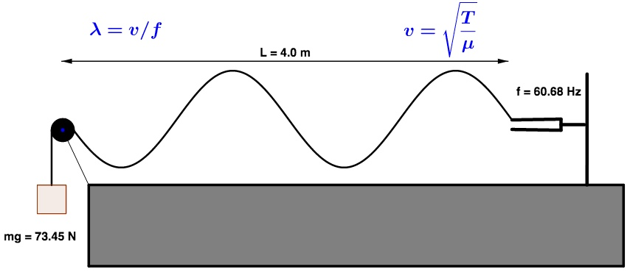

Figure 1: Experimental arrangements of vibrator or frequency fork, pulley, and masses.

Figure 2 shows the first four standing waves that are possible. From the figure it is clear that $n$ is the number of segments of half wavelengths in each standing wave. Solving Equation 1 for the possible values of the wavelength $λ$ gives
$$λ=2L/n,n=1,2,3,4,...$$ | $$\left(2\right)$$

Because the frequency is fixed at 45 Hz, each different standing wave will have a different wave speed $V$. The wave speed is determined by the string tension $T$ and the string mass per unit length $μ$.

$$V=\sqrt{\frac{T}{μ}}$$ | $$\left(3\right)$$

The frequency, wavelength, and speed are related by $V=fλ$. Using that and the speed $V$ from equation 3 gives

$$λ=\frac{1}{f}\sqrt{\frac{T}{μ}}$$ | $$\left(4\right)$$

The experimental arrangement differs slightly from the ideal situation because the node at the vibrator end of the string is moving up and down rather than being fixed in space. This effect means that the end of the string is moving up and down rather than being fixed in space. This effect means that the wavelength is somewhat difficult to define. For example, in the case $n=2$ the node will not be exactly in the center fo the string, and each of the segments will be slightly different in length. The effect decreases with each additional to the number of segments. One way to account for this effect is to determine the wavelength using only those segments that do not include the vibrator. Because it is somewhat difficult to locate the nodes precisely, there is usually less error involved if we assume that each wavelength is the total length of the string divided by the number of segments. That is the assumption we will make in this laboratory.
In other cases we will measure the harmonic wave traveling along the x-axis described by the equation
$$y=Asin\left(\frac{2πx}{λ}\right)$$ | $$\left(5\right)$$

where, $A$ is the amplitude of the wave, $λ$ is the wavelength of the wave in meters, and $x$ is the longitudinal position, respectively. For the percentage error, normally this will be done by calculating your measurement compared to the given known value. If $E$ stands for the experimental value, and $K$ stands for the known value, then the percentage error is given by

$$\%Error=\frac{\left|E-K\right|}{K}×100\%$$ | $$\left(6\right)$$
The values of the standard deviation from the mean for the frequency, $σ_{n-1}^{f}$, is given by the equation

$$σ_{n-1}^{f}=\sqrt{\frac{1}{n-1}\overset{n}{\underset{1}{∑}}{\left(f_{i}-\overline{f}\right)}^{2}}$$ | $$\left(7\right)$$
The precision of the mean for $\overline{f}$ is given by quantities called the standard error, $α_{f}$. The quantity is defined by the following equation:

$$α_{f}=\frac{σ_{n-1}^{f}}{\sqrt{n}}$$ | $$\left(8\right)$$
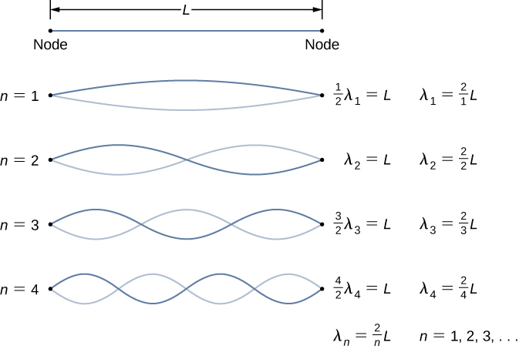
The meaning of $α_{f}$ is that, if the errors are only random, there is a 68.3% chance that the true value of the frequency lies within the range $\overline{f}±α_{f}$.

Figure 2: First four standing waves for waves in a string.

Equipment

- oPhysics Simulations Website (Standing Waves on a String-lab)
- Excel Data Template in Canvas

Procedure

- To determine the mass needed to produce a particular standing wave, it will help to pull down slightly or lift up slightly on the mass holder to determine if mass needs to be added or subtracted. Determine to the nearest $1g=0.001kg$ the mass needed to produce the largest possible amplitude of vibration with $n=3$. Record the value of the mass $M$ in the Data Table for $n=3$. Note the nodes with $n=1$ and $n=2$ require such a high string tension that the string is likely to break.
- Remove mass, determine to the nearest $1g=0.001kg$ the mass needed to produce the largest amplitude with $n=4$, and record that mass value in the Data Table.
- Continue the process of removing mass to produce standing waves for the cases of $n=5,6,7,8,$ and $9$. In each case $n$ refers to the number of segments into which the string length is divided. For each case determine the mass needed (to the nearest $1g=0.001kg$) to produce the largest amplitude. Record all values of mass in the Data Table.
- Use the value of $L$ in Equation 2 to calculate the wavelength $λ$ for each of the standing waves $n=3$ through $n=9$ and record the results in the Calculations Table.
- From the measured values of $M$ calculate the tension $T=Mg$ with $g=9.80m/s^{2}$. Record the values of $T$ in the Calculations Table.
- Calculate the values of $\sqrt{T}$ for each of the values of $T$ and record them in the Calculations Table. Note that when taking the square root, generally an extra significant figure is allowed in the value of the square root. For example, if a measure tension $T$ were $7.83$, then the recorded value of $\sqrt{T}$ should be $7.829$.
- From the measured values of $λ$ $\left(m\right)$ calculate the amplitude using from the equation 5 for each antinode or standing waves $n=1$ through $n=9$ and record the results in the Calculations Table 2.
- Plot all antinode in Excel from $n=1$ through $n=9$ in one single plot. The distance in meters as the horizontal axis and the amplitude in the vertical axis. Please follow the same example in Figure 3.
- According to Equation 4, $λ$ should be proportional to $\sqrt{T}$ with $\frac{1}{f}\frac{1}{\sqrt{ρ}}$ as the constant of proportionality. Perform a linear least squares fit with $λ$ as the vertical axis and $\sqrt{T}$ as the horizontal axis. Record the slope of the fit in the Calculations Table 1. Equate the slope to $\frac{1}{f}\frac{1}{\sqrt{ρ}}$, treating $f$ as unknown. Use the known value of $ρ$ to solve the resulting equation for $f$. Record that value of the frequency as $f_{exp}$ in the Calculations Table 1. Also record the value of $r$ the correlation coefficient in the Calculations Table 1.
- Calculate and record the percentage error of $f_{exp}$ compared to the know value of the frequency $f=120Hz$.

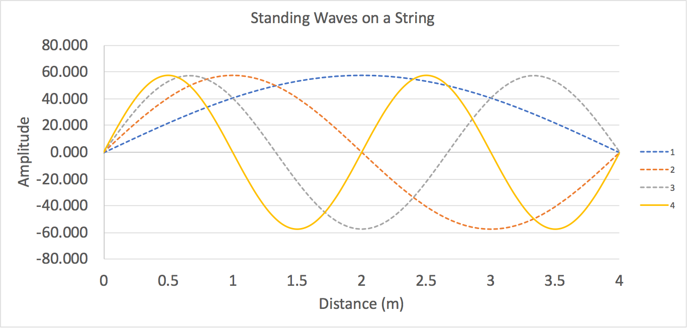

Figure 3: First four antinodes in a string using equation 4. The dash line represents the missing data from the simulation.

Data Recording

$$n$$ | M (g) | M (kg)
4
5
6
7
8
9
$$ρ=kg/m^{3}$$ | $$L=cm=m$$
Data Table

Plot your data in Excel from Calculations Table. Perform a linear least squares fit with $λ$ as the vertical axis and $\sqrt{T}$ as the horizontal axis.

Calculations Table 1
$$n$$ | $$T=Mg\left(N\right)$$ | $$λ\left(cm\right)$$ | $$λ\left(m\right)$$ | $$\sqrt{T}\left(\sqrt{N}\right)$$
1 | No Data |  |  | No Data
2
3
4
5
6
7
8
9
Slope = |  |  | $$r=$$
$$f_{exp}=$$ | $$Hz$$ |  | $$\%Error=$$

Calculations Table 2
 | Number of antinodes, $n$
Distance (m) | 1 | $$…$$ | 9
0
0.1
0.2
0.3
$$⋮$$
4.0

Plot all antinode in Excel from $n=1$ through $n=9$ in one single plot. The distance in meters as the horizontal axis and the amplitude in the vertical axis.

Questions

- What is the accuracy of your experimental value for the frequency? State clearly the basis for your answer.

- For the way in which the data were analyzed, the precision of the measurement would be related to the uncertainty of the measured slope. Instead, use each measurement of $T$ and $λ$ to calculate an independent value for the frequency $f$. Calculate the six values of the frequency using the equation $f=\left(1/λ\right)\sqrt{T/μ}$. Calculate the mean and standard error of those six values of the frequency and use that to comment on the precision of the measurements of $f$.

- Calculate the velocity for $n=4$ and for the $n=9$ standing wave.

- Calculate the tension $T$ that would be required to produce the $n=1$ standing wave in your string. In particular, does that much force break the string?

- Suppose that the string stretched significantly as the tension was increased. How would it affect the value of $μ$ for the string? How would it affect the results, and would it cause an error in the direction of your observed experimental error?

